My Lai Photographs from Life magazine, December 5, 1969

In December 1969, a picture essay in Life, one of the largest mass circulation magazines in the U.S., opened the floodgates of media coverage. Adding captions, Life published the pictures of army photographer, Ronald Haeberle, most of which appear below.

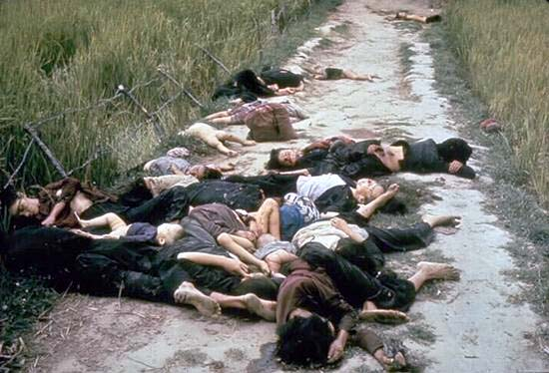

Haeberle found these bodies on a road leading from the village. "Most were women and babies. It looked as if they tried to get away."

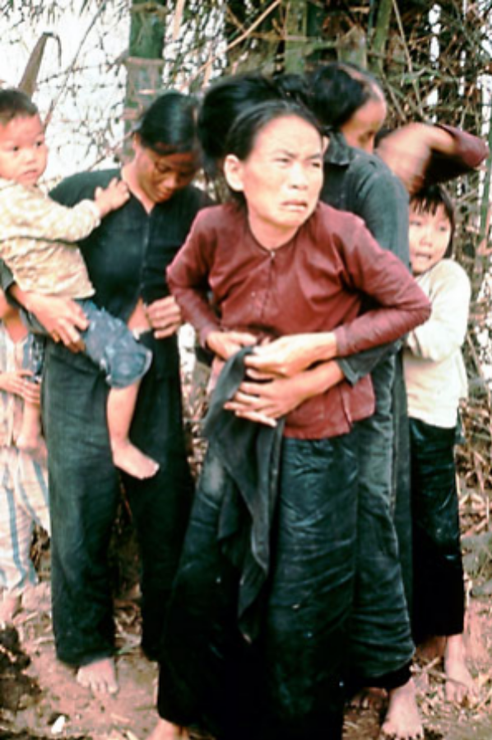 | "Guys were about to shoot these people," photographer, Ron Haeberle remembers. "I yelled, 'Hold it,' and shot my picture. As I walked away, I heard M16s open up. From the corner of my eye I saw bodies falling, but I didn't turn to look."

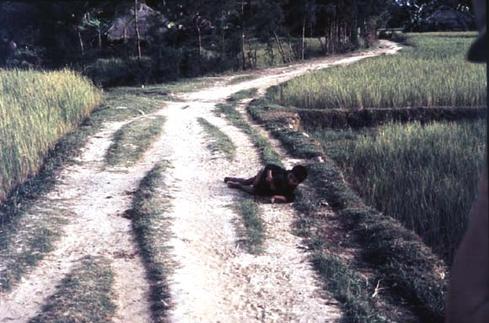
"When these two boys were shot at," says Haeberle, "the older one fell on the little one, as if to protect him. Then the guys finished them off."

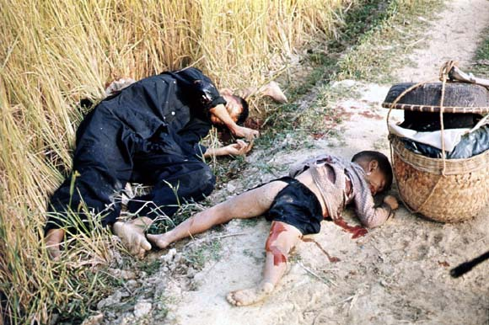

"This man and two little boys popped up from nowhere. The GIs I was with opened up, then moved in close to finish them."

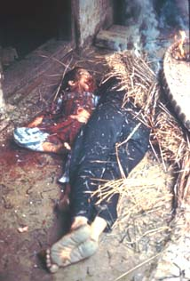 | "To us they were no civilians," said SP4 Varnado Simpson. "They were VC sympathizers. You don't call them civilians. To us they were VC. You don't have any alternatives. If they were VC and got away, then they could turn around and kill you."

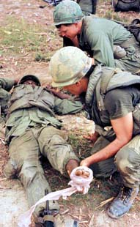 | A black GI told Haeberle he couldn't stomach it, he had to get out of there. Later Haeberle and Roberts were sitting near a ditch, a clump of bodies off to the left, when they heard a shot. They hit the ground, thinking it was a sniper. The soldier who had wanted to get out had shot himself in the foot with a .45. Accidentally, he said. "He shot himself purposely to get out of there," says Roberts. "He looked happy even though he'd shot up his own foot."

Source: Ronald L. Haeberle, "The Massacre at My Lai," LIFE vol. 67, December 5, 1969.

