**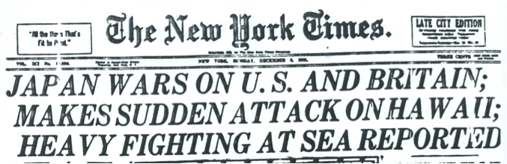Should the U.S. have dropped the atomic bomb on Japan?**

As the League of Nations and Stimson Doctrine attempts at influencing Japan and their endeavors, it seems as if war will happen…When? And what will be the circumstances?

A. The Sinking of the Panay (1937)

*“At 11:00 next morning (12 December 1937) Panay and three tankers anchored near Hoshien, upstream from Nanking. American flags were hoisted on their masts and painted on the awnings and topsides. The day was clear, sunny arid still. The crew ate their Sunday dinner. No guns were manned or even uncovered. Shortly after 13:30, three Japanese Navy bombing planes few overhead and released eighteen bombs, one of which disabled Panay's gun, wrecked the pilothouse, sick bay and fire room, wounded the captain (Lt. Com.Hughes) and several others. Immediately after, twelve more planes dive-bombed and nine fighters passed, making several runs over a space of twenty minutes. She fought back with her .30-cal. machine guns. By 14:06 all power and energy were lost…Captain Hughes saw that his ship was going down, he ordered her to be abandoned. Japanese planes hit the boats on their way to shore, and even combed the reeds along the riverbank for survivors. Two of the three* ***oil barges*** *were also bombed and destroyed. The Panay survivors,* ***kindly treated by the Chinese****, managed to get word through to Admiral and were taken on board U.S.S. Oahu and H.M.S. Ladybird two days later. Two bluejackets and one civilian passenger died of their wounds, eleven officers and men were seriously wounded.”*

* Account by Mr. George Atcheson Jr, Second Secretary of the American Embassy, who was a passenger; report of Court of inquiry held by Admiral Yarnell on U.S.S Augusta off Shanghai, 23 Dec. 1937.

B. Japanese Expansion in Southeast Asia

From: Tokyo (Foreign Minister)

To: Washington

July 31, 1941

Commercial and economic relations between Japan and third countries, led by England and the United States, are gradually becoming so horribly strained that we cannot endure it much longer. Consequently, our Empire, to save its life, must take measures to secure the raw materials of the South Seas. Our empire must immediately take steps to break asunder this ever-strengthening chain of encirclement, which is being woven under the guidance and with the participation of England and the United States, acting like a cunning dragon seemingly asleep. That is why we decided to obtain military bases in French Indo-China and to have our troops occupy that territory.

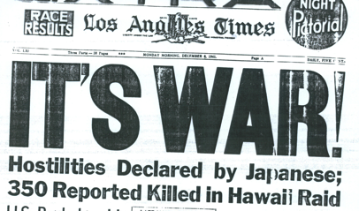C. U.S. Military Exercises in the Pacific

Although the U. S. had remained neutral as World War II continued into 1940, the nation was moving closer to direct involvement. We were aware of Tokyo’s aggression in China and eager to show support for Britain’s interests in Asia. FDR ordered the Pacific fleet to conduct its spring maneuvers in Hawaiian waters. Some military and civilian officials questioned his decision because they were worried about putting the fleet in harm’s way. When FDR direct that the ships would remain at Pearl Harbor for an indefinite stay some advisors feared that what FDR

intended as a deterrent would actually be seen as a challenge to Japan.

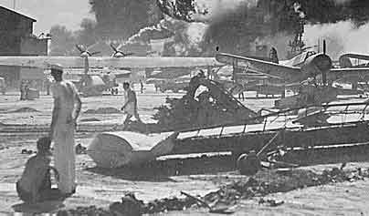D. Pearl Harbor Bombing

Sunday morning, December 7, 1941 - [Pearl Harbor,](http://www.thehistorychannel.co.uk/site/encyclopedia/article_show/Pearl_Harbor/m0012261.html?from=hotlink" \t "_SELF) Hawaii

* Over 400 planes from six Japanese carriers bombed the harbor and airfield, and within two hours much of the American Pacific fleet was rendered useless. Losses were devastating: Five of eight battleships, three destroyers, and seven other ships were sunk or severely damaged, and more than half the island's aircraft were destroyed.
* Fortunately for the Americans, all three U.S. Pacific fleet carriers were out at sea.
* A total of 2,400 Americans were killed and 1,200 were wounded in the attack. Japan's losses were 29 planes and four midget submarines.

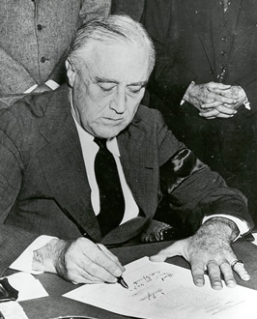E. “A Date Which Will Live in Infamy” - FDR Asks for a Declaration of War

“Mr. Vice President, and Mr. Speaker, and Members of the Senate and House of Representatives:

Yesterday, December 7, 1941 - a date which will live in infamy - the United States of America was suddenly and deliberately attacked by naval and air forces of the Empire of Japan.

The United States was at peace with that Nation and, at the solicitation of Japan, was still in conversation with its Government and its Emperor looking toward the maintenance of peace in the Pacific. Indeed, one hour after Japanese air squadrons had commenced bombing in the American Island of Oahu, the Japanese Ambassador to the United States and his colleague delivered to our Secretary of State a formal reply to a recent American message. And while this reply stated that it seemed useless to continue the existing diplomatic negotiations, it contained no threat or hint of war or of armed attack.

It will be recorded that the distance of Hawaii from Japan makes it obvious that the attack was deliberately planned many days or even weeks ago. During the intervening time the Japanese Government has deliberately sought to deceive the United States by false statements and expressions of hope for continued peace.

The attack yesterday on the Hawaiian Islands has caused severe damage to American naval and military forces. I regret to tell you that very many American lives have been lost. In addition American ships have been reported torpedoed on the high seas between San Francisco and Honolulu.

Yesterday the Japanese Government also launched an attack against Malaya.   
Last night Japanese forces attacked Hong Kong.   
Last night Japanese forces attacked Guam.   
Last night Japanese forces attacked the Philippine Islands.   
Last night the Japanese attacked Wake Island. And this morning the Japanese attacked Midway Island.

Japan has, therefore, undertaken a surprise offensive extending throughout the Pacific area. The facts of yesterday and today speak for themselves. The people of the United States have already formed their opinions and well understand the implications to the very life and safety of our Nation.

As Commander in Chief of the Army and Navy I have directed that all measures be taken for our defense.

But always will our whole Nation remember the character of the onslaught against us.

*(Applause…)*

No matter how long it may take us to overcome this premeditated invasion, the American people in their righteous might will win through to absolute victory. (*Applause…)*

I believe that I interpret the will of the Congress and of the people when I assert that we will not only defend ourselves to the uttermost but will make it very certain that this form of treachery shall never again endanger us. (*Applause…)*

Hostilities exist. There is no blinking at the fact that our people, our territory, and our interests are in grave danger.

With confidence in our armed forces- with the unbounding determination of our people- we will gain the inevitable triumph- so help us G-d. (*Applause…)*

I ask that the Congress declare that since the unprovoked and dastardly attack by Japan on Sunday, December 7, 1941, a state of war has existed between the United States and the Japanese Empire. (*Applause…)*

Note: The next day, while Japan had launched an all out Pacific attack, Great [Britain](http://www.thehistorychannel.co.uk/site/encyclopedia/article_show/Britain/m0004048.html?from=hotlink" \t "_SELF) and the United States declared war on [Japan.](http://www.thehistorychannel.co.uk/site/encyclopedia/article_show/Japan/m0019799.html?from=hotlink" \t "_SELF) A day later Germany and Italy declared war on the United States (already in war with Britain).

**Did Truman Commit Crimes Against Humanity**

**When He Dropped the Bomb on Japan?**

A. Background

As WWII came to an end, the only enemy left for the Allied Powers was Japan. In 1944, the Allied Powers gained victories against the Japanese forces and advanced through the islands of the Philippine Sea towards Japan. On April 12th, 1945, President Roosevelt died due to bleeding in his brain. Harry Truman took over as President during the war. President Truman met with other representatives from the Allied Powers in Potsdam, Germany, to discuss the surrender of Japan as well as the division of Germany among the Allied nations after the war. Japan refused to accept the terms of the surrender and the U.S. took action in early August of 1945.

“We call upon the government of Japan to proclaim now the unconditional

surrender of all Japanese armed forces, and to provide proper and adequate

assurances of their good faith in such action. The alternative for Japan

is prompt and utter destruction.” **– Potsdam Conference**

B. President Truman Defends his Decision to Drop the Atomic Bombs, August 1945

*“I realize the tragic significance of the atomic bomb. Its production and its use were not lightly undertaken...But we knew that our enemies were on the search for it. We know now how close they were to finding it. And we know the disaster which would come to this nation...to all civilizations, if they had found it first...*

*Having found the bomb we have used it. We have used it against those who attacked us without warning at Pearl Harbor, against those who have starved and beaten and executed American Prisoners of War (POWs), against those who have abandoned the pretense of obeying international laws of warfare. We have used it in order to shorten the agony of war, in order to save the lives of thousands and thousands of young Americans…”*

**How did Truman justify his use of the atomic bombs?**

C. Memorandum for the President, July 2,1945

RE: Japanese Invasion

If we once land on one of the main islands and begin a forceful occupation of Japan, we shall probably have cast the die (dice) of last-ditch resistance. The Japanese are highly patriotic and certainly susceptible to calls for fanatical resistance to repel (go against) an invasion. Once started in actual invasion, we shall in my opinion have to go through with an even more bitter finish fight than in Germany. We shall incur the losses incident (related) to such a war and we shall have to leave the Japanese islands even more thoroughly destroyed than Germany. This would be due both to the differences in the Japanese and German personal character and the differences in the size and character of the terrain through which operations will take place.

**Why must we attack Japan with full force?**

D. Scientists' Petition Against Use of the Atomic Bomb, June 1945

“Nuclear bombs cannot possibly remain a ‘secret weapon’ at the exclusive disposal of this country for more than a few years. The scientific facts on which their construction is based are well known to scientists of other countries. Unless an effective internal control of nuclear explosives is instituted, a race for nuclear armaments is certain to ensue following the first revelation of our possession of nuclear weapons to the world...In the war to which an armaments race is likely to lead, the United States, with its agglomeration (accumulation)of population and industry in comparative few metropolitan districts, will be at a disadvantage compared to nations whose population and industry are scattered over large areas.

We believe that these considerations make the use of nuclear bombs for an early, unannounced attack against Japan inadvisable. If the United States were to be the first to release this new means of indiscriminate destruction upon mankind, we would sacrifice public support throughout the world, precipitate the race for armaments, and prejudice the possibility of reaching international agreement on the future control of such weapons.”

**What were the arguments made by scientists against the use of atomic weapons?**

E. Manhattan Project (http://nuclearweaponarchive.org/Usa/Med/Med.html)

* Through 1940 and well into 1941, work accelerated in the U.S., and important discoveries accumulated although official interest and support languished. In February, 1941 Philip Abelson began actual development of a practical uranium enrichment system (liquid thermal diffusion) and on February 26 Glenn Seaborg and Arthur Wahl discover plutonium. During March the first American measurements of the U-235 fission cross section allow Peierls to calculate the first experimentally supported estimate of a critical mass for U-235 (18 lb as a bare sphere, 9-10 lb when surrounded by a reflector).
* This Manhattan Project predecessor, code named the S-1 project, headed by A. H. Compton. The core group of scientists that would lead the development of the atomic bomb had coalesced well before this, and was already working as hard as resources allowed on the problem.
* On September 3, 1941, with PM Winston Churchill's endorsement, the British Chiefs of Staff agree to begin development of an atomic bomb. But it is not until Dec. 18, after months of bureaucratic struggling and the U.S. entry into the war, that a U.S. project to investigate atomic weapons (as opposed to "study fission") finally starts.
* Despite its official founding in August, the Manhattan Project **really** began on September 17, 1942 when Col. Leslie Richard Groves was notified at 10:30 a.m. by Gen. Brehon Somervell that his assignment overseas had been cancelled. Groves, an experienced manager who had just overseen the colossal construction of the Pentagon, seized immediate and decisive control. In just two days he resolved issues that had dragged on for months under Compton. On September 18 Groves ordered the purchase of 1250 tons of high quality Belgian Congo uranium ore stored on Staten Island, and the next day purchased 52000 acres of land to be the future site of Oak Ridge. Groves was promoted to Brigadier General on September 23. By September 26 Groves had secured access to the highest emergency procurement priority then in existence.

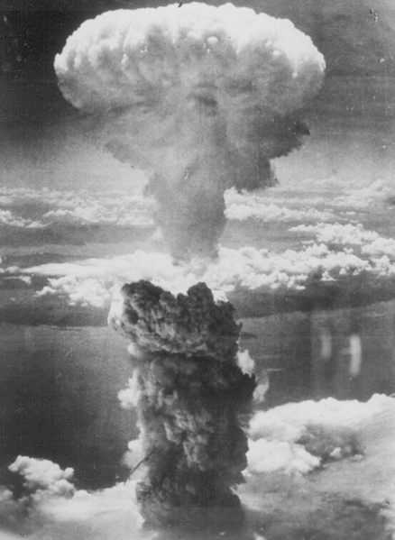F. Atomic Bomb Explosion…the Aftermath…

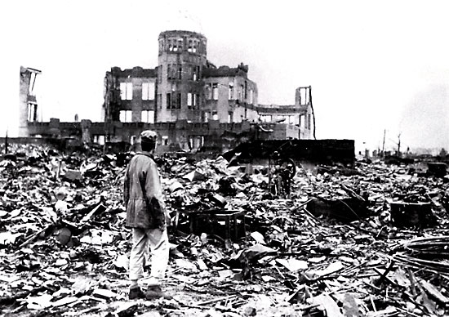

Aftermath in a town

Mushroom Cloud of Atomic Bomb

G. Hiroshima Victims Speak

1. “The streets were cluttered with parts of houses that had slid into it, and with fallen telephone poles and wires. From every second or third house came the voices of people buried and abandoned, who invariably screamed, with formal politeness, “Tasukete Kure!” – meaning “Help, if you please!” The priests recognizing several ruins from which these cries came out as the homes of friends, but because of the fire it was too late to help.”
2. “My face was so distorted and changed that people couldn’t tell who I was. After a while I could call others’ names but they couldn’t recognize me.”
3. “Suddenly, I wondered what had happened to my mother and sister. My mother was then forty five and my sister five years old. When the darkness began to fade, I found that there was nothing around me. My house, the next door neighbor’s house, and the next…all had vanished. I was standing amid the ruins of my house. No one was around. It was quiet, very quiet – an eerie moment.”
4. “While taking my severely wounded wife out to the riverbank by the side of the hill of Nakahiromachi, I was horrified, indeed, at the sight of the naked man standing in the rain with his eyeball in his palm. He looked to be in great pain, but there was nothing I could do for him.”
5. “A mother, driven half mad while looking for her child, was calling his name. At last she found him. His head looked like a boiled octopus. His eyes were half closed, and his mouth was white, swollen, and pursed.”

**In what ways were the people living in Japan affected by the bomb, according to the above accounts?**

H. The Universal Declaration of Human Rights, United Nations, 1948

**Article 5.**No one shall be subjected to torture or to cruel, inhuman or degrading treatment or punishment.

**Article 8.**Everyone has the right to an effective remedy by the competent national tribunals for acts violating the fundamental rights granted him by the constitution or by law.

**Article 25.**Everyone has the right to a standard of living adequate for the health and well-being of himself and of his family, including food, clothing, housing and medical care and necessary social services, and the right to security in the event of unemployment, sickness, disability, widowhood, old age or other lack of livelihood in circumstances beyond his control.

**Why were these rights put into place by the United Nations?**

TASK: In your notebook, write a BRIEF newspaper article answering ONE of the following questions. Include a title, and EVIDENCE for your answers.

(1) Should Truman have dropped the bomb?

(2) Should he be held responsible for crimes against humanity?