AP US HISTORY

The Korean War (Containment Policy)
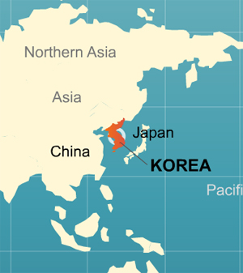
Background: After Korea was liberated from Japan in World War II, it was split into two countries along the 38th Parallel line of latitude. The northern country, known as the Democratic People’s Republic of Korea (or North Korea), was under the influence of the Soviet Union and became a communist dictatorship. The Southern country known as The Republic of Korea (or South Korea) was under the influence of the United States. On June 25, 1950, encouraged and heavily supplied (both in weapons and money) by the Soviet Union and China, North Korea invaded the South to try to conquer and unite both countries. The newly created United Nations led by United States generals and mostly United States soldiers quickly came to the aid of South Korea. This became the first proxy (third party) war of the Cold War.
In June , 1950, open warfare in Korea began between the Russian-dominated Korean People’s Republic (north of the 38th parallel) and the American-backed Republic of Korea. As the North Korean troops advanced rapidly southward, fear mounted that the acceptance of the situation would encourage communist aggression in Berlin, the Philippines, and the area south of Communist China. So, the United Nations Security Council adopted a resolution urging member nations to give South Korea assistance.
Two days later Truman ordered air and sea forces into action, at the same time instructing American fleet to keep off any attack from China. These acts were supported by many nations, and our Congress, in order to stop the advancement of communism (policy of containment).

UN Resolution, June 27th, 1950 (vote 9-0 without the Soviet Union present)
The Security Council,
HAVING DETERMINED (decided) that the armed attack upon the Republic of Korea by forces from North Korea constitutes (makes up) a breach of peace;
HAVING CALLED UPON the authorities in North Korea to withdraw forthwith their armed forces to the 38th parallel, and
HAVING NOTED from the report of the United Nations Commission for Korea that the authorities in North Korea have neither ceased (ended) hostilities nor withdrawn their armed forces to the 38th parallel and that urgent military measures are required to restore international peace and security, and
HAVING NOTED the appeal from the Republic of Korea to the United Nations for immediate and effective steps to secure peace and security,
RECOMMENDS that the Members of the United Nations furnish (provide) such assistance to the Republic of Korea as may be necessary to repel (keep off) the armed attack and to restore international peace and security in the area.

Cause of the War | Details of the War | Outcome of the War
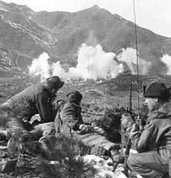 | 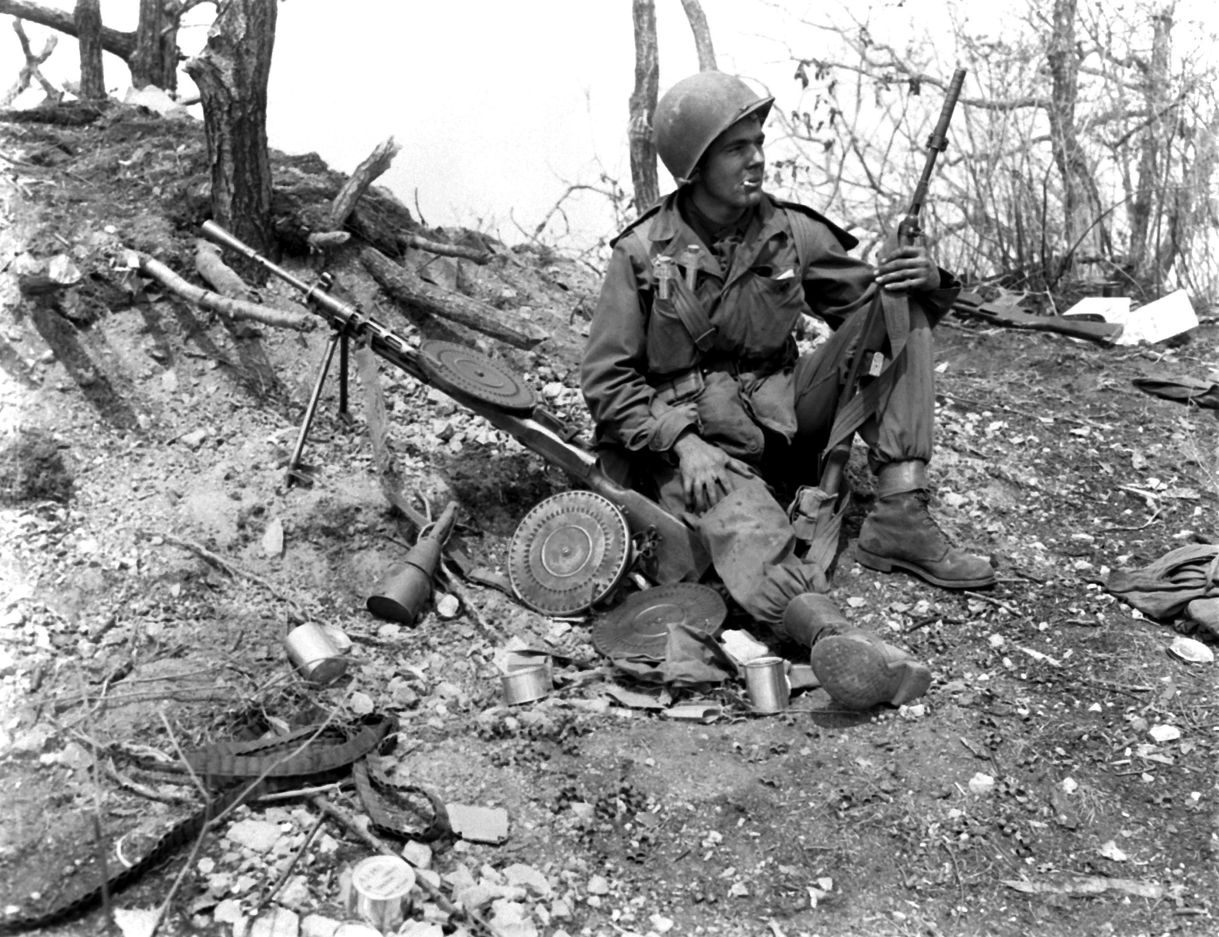 | 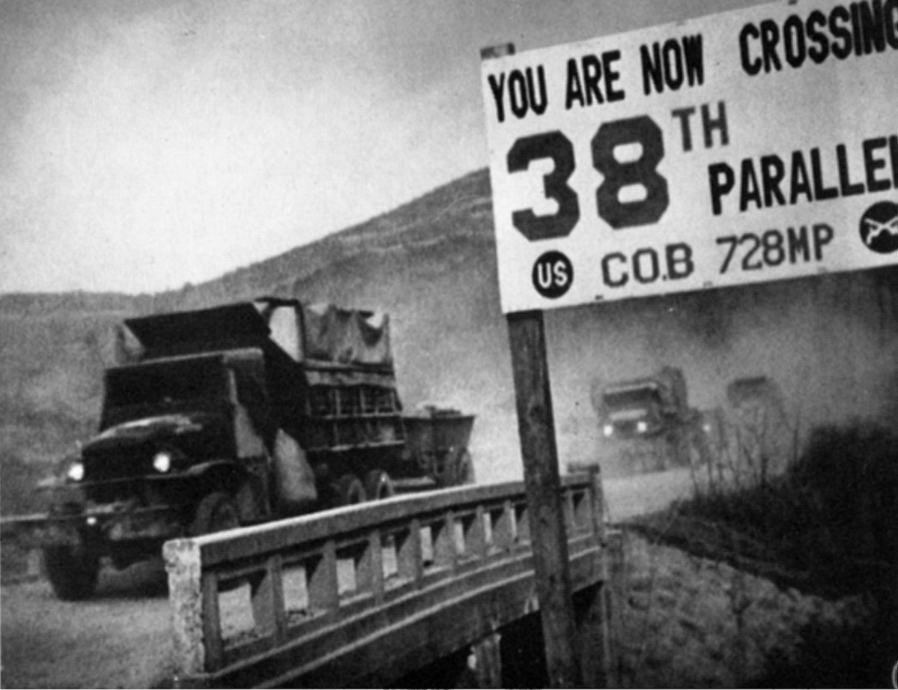

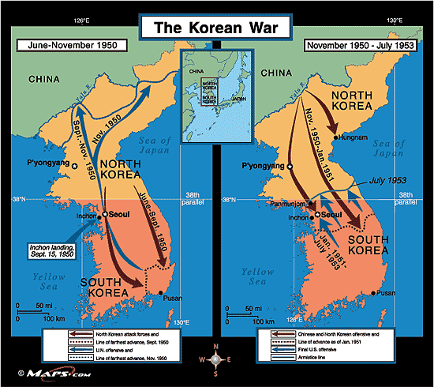

“On 25 June 1950, the young Cold War suddenly turned hot, bloody and expensive. Within a few days, North Korea's invasion of South Korea brought about a United Nations' "police action" against the aggressors. That immediately produced heavy military and naval involvement by the United States. While there were no illusions that the task would be easy, nobody expected that this violent conflict would continue for more than three years.” (www.history.navy.mil)

US/NORTH KOREA RELATIONS TODAY:
North Korea remains a closed, totalitarian state, widely regarded as a threat to world peace. South Korea is an economic miracle, America’s seventh largest trading partner and staunchest ally. By 1995, she had become the world’s eleventh strongest economy and the fifth largest producer of automobiles. For once, in their long history, able to act solely in their own national interest, they have produced an astounding level of prosperity, with the freedom to enjoy it.
Recently North Korea has tested their nuclear technology over Pacific waters; threatening Japan – who is still under the U.S. nuclear umbrella as our ally. March 2013, North Korea declares 1953 Armistice invalid.
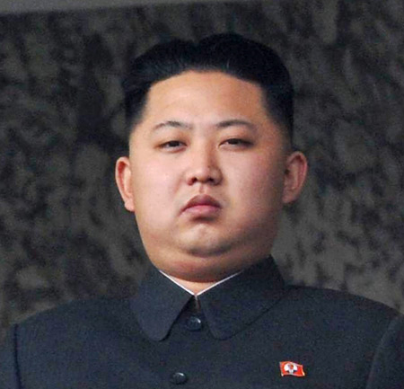
Kim Jong Un: Current leader of North Korea

DOCUMENT 3 Revolution in China
China, because of its large population and abundant natural resources, has played a significant role in international affairs since the eighteenth century. However, during its long war with Japan during World War II, China was severely weakened. The Chinese suffered over two million casualties, in addition to significant damage to private property and the nation's infrastructure. The Chinese morale and standard of living were greatly diminished, and China was ripe for a revolution.
During WWII, China was ruled by a nationalist government headed by Jiang Jieshi (Chiang kai-shek). At this time, the U.S. and China had a weak alliance, and the U.S. provided token support for their nationalist government. A communist movement led by the dynamic leader Mao Zedong (Mao Tse-tung) that had started before the war was quickly sweeping the country. Many Chinese citizens blamed Jiang for not preventing the decimation caused by WWII and were quick to accept Mao's bold promises. Mao was backed economically, socially, and militarily by the Soviet Union, and his loyalists grew exponentially. He quickly amassed a huge militia and began a revolution for control of the Chinese government.
Initially, Jiang's armies were able to suppress the larger but poorly trained revolutionary armies. However, poor decisions, divided loyalties, and corruption doomed the Nationalist Party, which began to break apart. Meanwhile, Soviet weapons and supplies continued to support Mao's rapidly growing armies. The "Red" Army began a rapid assault on the southern part of China. Disillusioned nationalist troops provided little resistance, and many enlisted with the communists. By 1949, Jiang's military defenses were decimated, and the leaders of the Nationalist Party were forced to flee to Taiwan to save their lives.
In light of the U.S. commitment to the Cold War policy of containment, the communist victory in China shocked and alarmed Americans. Many Americans viewed the fall of the Chinese government as a loss for America. China's population of 500 million people represented 25 percent of the world's population. Many Americans felt as if the balance of power in the Cold War had shifted toward the communists.
Republicans seized the opportunity to politicize the issue, blaming Truman and the Democratic Congress for the fall of China. They accused the Democrats of having communist sympathizers within the Party who discouraged Truman from providing the aid that Jiang needed to fight the communists. Republicans claimed that Truman's administration should have taken a proactive role in building relations with China. They argued that China was a key ally that should have been preserved at any cost.
The Democrats reacted fiercely to the Republican allegations and immediately declared that China was not theirs to lose. They argued that China was never fully controlled by Jiang and many of his supporters had deserted him. Democrats further asserted that the U.S. and China did not have a strong enough relationship to allow Truman to exert the influence needed to prevent the fall of China. They maintained that no amount of U.S. influence would have prevented the fall of China.
The U.S. was not alone in its concern over a communist China. Many western Allies joined the U.S. in its refusal to recognize the Peoples' Republic of China in the United Nations. America, France, Britain, and other U.N. powers continued to acknowledge Jiang as the rightful leader of China, even though he was exiled and powerless in Taiwan.
The Soviet Union was furious at the West's reluctance to recognize Chairman Mao's government in the United Nations. Stalin ordered Soviet ambassadors to the United Nations to immediately boycott the organization. The Soviet Boycott threw the U.N. into disarray and limited its ability to be effective. The Soviets ended their boycott and rejoined the U.N. Security Council on August 1, 1950, although communist China was not recognized as a member of the U.N. Security Council until 1973.

DOCUMENT 1 Korean War Buildup
President Harry Truman’s Statement on the Situation in Korea
“In my generation, this was not the first occasion when the strong had attacked the weak. I recalled some earlier instances: [Japan in] Manchuria, [Italy in] Ethiopia, [Germany in] Austria. I remembered how each time that the democracies failed to act it had encouraged the aggressors to keep going ahead. Communism was acting in Korea just as Hitler, Mussolini, and the Japanese had acted ten, fifteen, twenty years earlier. I felt certain that if South Korea was allowed to fall, Communist leaders would be emboldened to override nations closer to our shores. If the Communists were permitted to force their way into the Republic of Korea without opposition from the free world, no small nation would have the courage to resist threats and aggression by stronger communist neighbors. If this was allowed to go unchallenged it would mean a third world war, just as similar incidents had brought on the Second World War. It was also clear to me that the foundation and principles of the United Nations were at stake unless this unprovoked attack on Korea could be stopped.”
The Korean people and landscape were devastated by the extreme cruelty of the Japanese military during World War II. At the conclusion of the war, Japanese forces surrendered to both the U.S. and the Soviet Union in Korea. The surrendered left the USSR in control of the territory north of the 38th parallel and the U.S. in control of the territory to the south of the 38th parallel. Although the U.S. and the Soviet Union proclaimed to seek a unified Korea, both countries retained a sizable military presence. The United States and the Soviet Union engaged in nation building and established regimes on their respective sides of the 38th parallel and supplied these new regimes with weapons, supplies, and training. Eventually the U.S. and the Soviets withdrew from Korea but they left behind a divided country that by 1950 was on the brink of war.
The United States attempted to avoid conflict by completely removing troops from Korea. The U.S. had a large military presence in Japan and the Philippines, which they felt was capable of addressing any hostility in Asia. The United States was concerned that a continuing military presence in Korea could be construed as an act of aggression by North Korea, China, or the Soviet Union. Secretary of State Dean Acheson declared that Korea was outside of the U.S. defensive perimeter, which essentially isolated South Korea from U.S. protection.
After the U.S. withdrawal, South Korea became vulnerable to North Korean aggression. North Korea's leader, Kim II-Sung, was taking advantage of Soviet assistance to increase his military might. On June 25, 1950, North Korean forces armed with Soviet-made equipment crossed into South Korea. Kim II-Sung's soldiers were much better trained and equipped than their South Korean counterparts. The South Korean military was immediately overwhelmed and driven south to the coastal town of Pusan. South Korea now literally had its back to the wall and faced certain defeat without outside intervention.
In April of 1950, the National Security Council proposed, in a policy paper known as NSC-68, a huge increase in U. S. military spending. The goal of NSC-68 was to guarantee the United States was able to enforce its containment policy not just in Korea but also around the globe through investment in both conventional and nuclear forces. At the time, since there was no immediate military crisis and the cost of the measures proposed were so high, Congress did not act on the recommendations. After the North Korean invasion, Truman immediately resurrected the proposal and called for a 350 percent increase in the military budget. He also called for increasing the number of troops to three and a half million.
The United States authored a United Nations Security Council proposal condemning North Korea's aggression and pledging U.N. support to "render every assistance" to restore peace. The proposal was unanimously passed by all nine attending nations. Due to their earlier boycott of the U.N. in protest of the non-recognition of communist China, the Soviet representative was conspicuously absent that day and unable to cast a vote.
President Truman was greatly concerned by North Korea's aggression and feared that it would trigger another world war. The open-ended United Nations resolution allowed Truman to act militarily. Without consulting Congress, Truman ordered American Air Force and Naval units to support South Korea. The U.N. resolution also allowed Truman to appoint a commander of the U.N. forces. Truman immediately ordered General Douglas MacArthur and his troops to leave their post in occupied Japan and support the overmatched South Korean troops. This military operation was ostensibly under the control of the United Nations although 90 percent of troops, supplies, and money were American.

DOCUMENT 4 Korean War
President Truman Explains the Need for Limited War (April 11, 1951)
“So far by fighting in a limited war in Korea we have prevented aggression from succeeding and bringing general war…We do not want to see the conflict in Korea extended. We are trying to prevent a world war – not start one…But you may ask: Why can’t we take other steps to punish the aggressor? Why don’t we drop an atomic bomb on Manchuria and China itself? If we do these things we would be running a very grave risk of starting a general war…we would become involved in a very complicated conflict on the continent of Asia. What would please the Soviet Union more than for our military forces to be committed to a full scale war with Red China (China became communist in 1949)?”
General Douglas MacArthur and his United Nations troops joined the South Korean forces that were backed up in Pusan, near the southernmost part of South Korea. MacArthur knew that confronting the confident North Koreans at Pusan would be difficult and costly. On September 15, 1950, MacArthur launched a large-scale amphibious assault on the rear of the North Korean lines near Inchon. The North Koreans were surprised by MacArthur's bold strategy and were caught unprepared. The North Korean troops suffered heavy casualties and were driven north of the 38th parallel by the South Korean and American troops.
MacArthur and the South Koreans were eager to defeat the North Koreans. MacArthur asked Truman for permission to allow troops to pursue North Korean forces north of the 38th parallel. Truman was reluctant to invade North Korea, as the initial U.N. objective was to "contain" North Korea and restore the border between the North and South. However, presented with the opportunity to prevent future North Korean incursions, Truman and the United Nations allowed forces to enter North Korea with the caveat that they were not to engage Soviet or Chinese forces. MacArthur, in a critical miscalculation, doubted that the Chinese or Soviets would directly intervene, and he boldly advanced into North Korea with the goal to end the war decisively.
General MacArthur Presents his Views to Congress (April 10, 1951) [adapted]
“Once war is force upon us, there is no alternative (other option) to applying every available means (way) to bring a swift or quick end to the war. War’s very objective is victory! In war there can be no substitute for victory. I felt that military necessity in the conduct of war made necessary:
- The increase of our economic blockade against China,
- A naval blockade against the China coast,
- Removal of restrictions on air attack on China,
- Removal of restrictions on the forces against the Chinese mainland.”
MacArthur's U.N. forces advanced rapidly and quickly became overextended. After warnings from the Chinese went unheeded, over 300,000 Chinese "volunteers" attacked the U.N. troops, inflicting numerous casualties and driving them back to the 38th parallel. MacArthur was enraged and humiliated by his defeat and called on Washington to blockade China and bomb its military bases. Truman's administration was leery of extending the war or directly engaging the Chinese or angering the Soviets.
Truman and the U.N. ordered MacArthur to fight a "limited war." They feared that any attack on China would prompt the USSR to retaliate in Europe or Asia. Truman also announced that nuclear weapons would not be used against Korea or its allies. The ultimate goal of the U.N. forces was to restore the original border between North and South Korea and establish a peaceful resolution.
MacArthur was furious and felt that a limited war would not allow his troops to win the war or achieve his objectives. MacArthur began publicly questioning Truman's policies and leadership with pronouncements like, "there is no substitute for victory." His statements grew more bold and critical, leaving Truman which no choice but to relieve him of command. MacArthur returned home to a hero's welcome, and the American public viewed him as a brilliant commander. Public sentiment had turned against Truman, and some began to view him as a fool and a communist sympathizer.
Informal preliminary peace talks began in Korea in July of 1951. There was little progress on the many divisive issues such as prisoner exchange, and the talks quickly disintegrated. Unofficial discussions continued sporadically for the next two years but were largely unproductive. Meanwhile, fierce fighting continued and the number of casualties on both sides of the conflict rapidly grew.

DOCUMENT 2 Korean War Aftermath
President Truman worked tirelessly to resolve the conflict in Korea. However, Truman's extreme unpopularity forced him not to seek re-election in 1952. His term in office expired in 1953, and he intended to bring the troops home before the end of his administration but was unable to because of delayed peace talks.
The Republican Party chose General Dwight Eisenhower as their candidate in the election of 1952. A major tenet of Eisenhower's campaign was ending the war in Korea. He promised Americans that he would personally visit Korea and help negotiate a ceasefire. The American electorate wanted to see an end to the war in Korea, and they elected President Eisenhower in 1952 based on his promise to do so.
Eisenhower lived up to his promise and traveled to Korea within weeks of taking office. However, the peace talks continued to make little progress, and Eisenhower grew increasingly frustrated. After determining that conventional discussions were not effective, Eisenhower played his trump card by threatening to use atomic weapons if the peace process did not advance. Eisenhower's sudden and very real threat alarmed both sides, and discussions rapidly advanced. After numerous and lengthy negotiations, a ceasefire between North and South Korea was signed on July 27, 1953.
Armistice (July 27th, 1953)
A Military Demarcation Line shall be fixed and both sides shall withdraw two kilometers from this line so as to establish (create) a Demilitarized Zone between opposing forces. A Demilitarized Zone shall be established as a buffer zone to prevent the occurrence of incidents that might lead to a resumption (continuing) of hostilities.

- This Armistice is still in effect today. No treaty has ever been signed declaring an end to the hostile military acts in Korea. This was never considered a war but rather a “police action.”
- 55,000 U.S. soldiers were lost in this three year war.
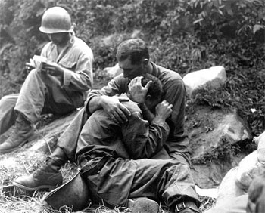

A grief stricken American infantry man whose buddy has been killed in action is comforted by another soldier, Haktong-Ni area, Korea, 1950.
Photo by SFC Albert Chang / US Army

The armistice signed between North and South Korea is still in effect today. The truce agreement restored the 38th parallel as the dividing boundary between the two countries. It also established a Demilitarized Zone (DMZ) between them. The DMZ is a two and a half mile wide by 155 mile long territory, directly on the 38th parallel. Both the north and south sides of the DMZ are heavily fortified, and thousands of soldiers on both sides patrol the boundary. There continues to be a tremendous amount of tension along the DMZ and there have been many near skirmishes, although significant problems have been avoided.
The United States was relieved that the conflict in Korea was over, but many Americans were dissatisfied with the conclusion. Americans proudly remembered their decisive victory in WWII and regretted the lack of a clear victory in Korea. The general consensus of the American public was that the war was ineffective, pointless, and very costly.
The Korean conflict produced a staggering number of casualties and victims. The U.S. military lost nearly 37,000 soldiers in the Korean War, while the other U.N. forces endured nearly 3,000 casualties. The combined U.N. forces also had approximately 103,000 combatants wounded. The Korean people suffered much greater losses. Over two million Korean civilians were killed during the conflict, mostly South Koreans. The North Korean and Chinese armies had over one and a half million combat fatalities. The total number of deaths directly resulting from the Korean War neared four million.
Despite devastating losses and lack of a clear victory, the Korean War was not a complete failure for the United States. The U.S. was able to demonstrate a key element of the Containment Policy by halting the spread of communism in Asia. Proving its dedication to the Containment Policy was possibly the greatest victory for the United States. The Soviet Union and China recognized that America was serious about stopping the spread of communism and that it was willing to pay great costs to confront it. As a new war flared up in Vietnam a few years after the Korean truce, U.S. policy-makers would rely on the apparent success of containment in Korea to dictate U.S. actions in Vietnam.

