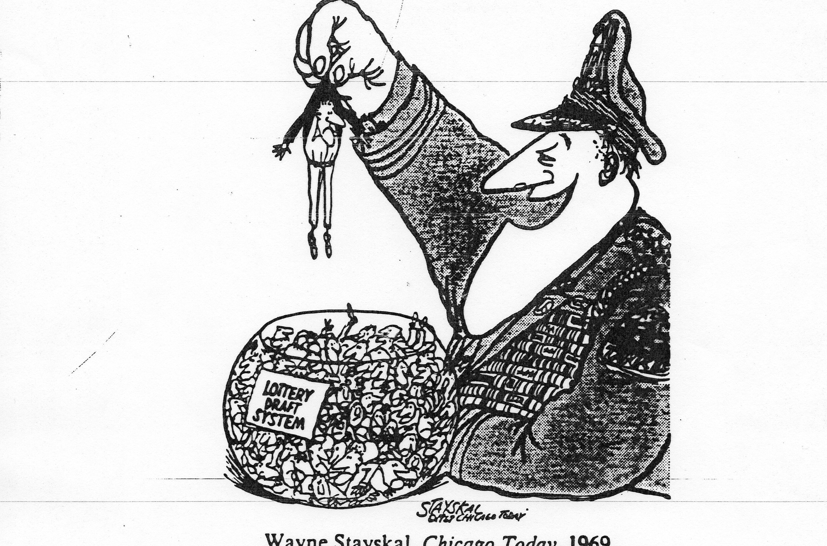
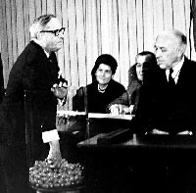
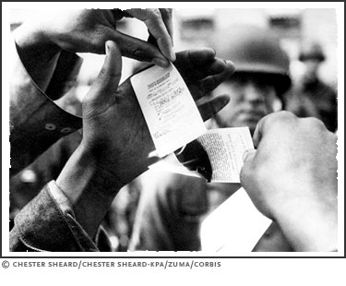
DOCUMENT #6 The Draft: “Happy Birthday to you. . .Happy Birthday to. . .
The Draft was a system where young men between the ages of 18 and 26 were forced into military service. The men were chosen to go to war by their birthday. The United States military would select a date and all men born on that date would be sent draft cards. In 1965, over 5,000 young men were being drafted each month. Originally, if selected, one could avoid going by entering a university as a full time student but this option did not last long. Eventually people began “dodging the draft” by leaving the country (many ran away to Canada) and burning their draft cards in protest. If caught draft dodging, one would be thrown in jail. The draft no longer exists, but to this day the United States government reserves the right to draft young men to war if necessary.

Draft cards [cards the U.S. government gives to men who have signed up for the draft] were burnt by young people protesting the war.
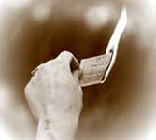
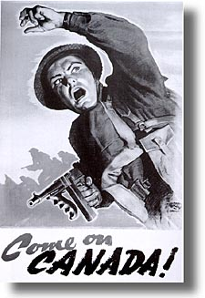
There were 366 blue plastic capsules containing birth dates placed in a large glass container and drawn by hand to assign order-of-call numbers to all men within the 18-26 age range specified in Selective Service law.

(1) United States v. O’Brien (1966); burning draft cards.
O'Brien burned his Selective Service registration certificate before a sizable crowd in order to influence others to adopt his antiwar beliefs. He was indicted, tried, and convicted for violating 50 U.S.C. App. § 462 (b), a part of the Universal Military Training and Service Act, subdivision (3) of which applies to any person "who forges, alters, knowingly destroys, knowingly mutilates, or in any manner changes any such certificate . . .." O’Brien claims that the speech was in protest to the war and that the military code was made specifically to limit free speech. Decision: Government right to have and maintain a military. Not allowed to protest in this way.

(2) John Kerry Vietnam Veterans Against the War Statement to the Senate Committee of Foreign Relations (4/23/1971)
Historical Context: Future Massachusetts Senator & Presidential candidate John Kerry served as a Lieutenant in the United States Navy during the Vietnam War from 1966 to 1970.
Kerry expressed his view that the war was essentially a civil war and that nothing in Vietnam was a realistic threat to the United States. He argued that the real reason for the continued fighting was political purposes: "Someone has to die so that President Nixon won't be, and these are his words, 'the first President to lose a war.'" That conclusion led him to ask: "[H]ow do you ask a man to be the last man to die in Vietnam? How do you ask a man to be the last man to die for a mistake?" The day after this testimony, Kerry participated in a demonstration with 800 other veterans in which he and other veterans threw their medals and ribbons over a fence at the front steps of the U.S. Capitol building to dramatize their opposition to the war. As Kerry threw his decorations over the fence, his statement was: "I'm not doing this for any violent reasons, but for peace and justice, and to try and make this country wake up once and for all."

(3) Wounded Soldiers
Throughout the war, many soldiers were injured or killed. A lot of these men were forcibly drafted into the war. Over the course of the war about 540,000 American troops were sent to Vietnam. Of those about 50,000 men were killed and countless others were physically and mentally wounded. Powell's experiences are all the stronger because he questioned his Christian faith during his tour. He asks himself how he can kill people, especially those not directly attacking him, and he comes to reconcile himself to shooting the enemy because they would kill him or his comrades if given the chance. At the same time, he is disgusted by his fellow soldiers' behavior, such as sharing a Viet Cong nurse whom they take turns raping before killing her. PTSD (Post Traumatic Stress Disorder) became part of Powell's life almost from his first day in Vietnam. When he was on leave, he could not function normally in an airport from fear of the people around him. When he returns home, he finds himself unable to confront people from fear and distrust, resulting in failed marriages and frequent career changes.”

FIND YOUR BIRTHDAY-  How soon was YOUR  turn to get drafted? | JAN | FEB | MAR | APR | MAY | JUNE | JULY | AUG | SEPT | OCT | NOV | DEC
1 | 305 | 086 | 108 | 032 | 330 | 249 | 093 | 111 | 225 | 359 | 019 | 129
2 | 159 | 144 | 029 | 271 | 298 | 228 | 350 | 045 | 161 | 125 | 034 | 328
3 | 251 | 297 | 267 | 083 | 040 | 301 | 115 | 261 | 049 | 244 | 348 | 157
4 | 215 | 210 | 275 | 081 | 276 | 020 | 279 | 145 | 232 | 202 | 266 | 165
5 | 101 | 214 | 293 | 269 | 364 | 028 | 188 | 054 | 082 | 024 | 310 | 056
6 | 224 | 347 | 139 | 253 | 155 | 110 | 327 | 114 | 006 | 087 | 076 | 010
7 | 306 | 091 | 122 | 147 | 035 | 085 | 050 | 168 | 008 | 234 | 051 | 012
8 | 199 | 181 | 213 | 312 | 321 | 366 | 013 | 048 | 184 | 283 | 097 | 105
9 | 194 | 338 | 317 | 219 | 197 | 335 | 277 | 106 | 263 | 342 | 080 | 043
10 | 325 | 216 | 323 | 218 | 065 | 206 | 284 | 021 | 071 | 220 | 282 | 041
11 | 329 | 150 | 136 | 014 | 037 | 134 | 248 | 324 | 158 | 237 | 046 | 039
12 | 221 | 068 | 300 | 346 | 133 | 272 | 015 | 142 | 242 | 072 | 066 | 314
13 | 318 | 152 | 259 | 124 | 295 | 069 | 042 | 307 | 175 | 138 | 126 | 163
14 | 238 | 004 | 354 | 231 | 178 | 356 | 331 | 198 | 001 | 294 | 127 | 026
15 | 017 | 089 | 169 | 273 | 130 | 180 | 322 | 102 | 113 | 171 | 131 | 320
16 | 121 | 212 | 166 | 148 | 055 | 274 | 120 | 044 | 207 | 254 | 107 | 096
17 | 235 | 189 | 033 | 260 | 112 | 073 | 098 | 154 | 255 | 288 | 143 | 304
18 | 140 | 292 | 332 | 090 | 278 | 341 | 190 | 141 | 246 | 005 | 146 | 128
19 | 058 | 025 | 200 | 336 | 075 | 104 | 227 | 311 | 177 | 241 | 203 | 240
20 | 280 | 302 | 239 | 345 | 183 | 360 | 187 | 344 | 063 | 192 | 185 | 135
21 | 186 | 363 | 334 | 062 | 250 | 060 | 027 | 291 | 204 | 243 | 156 | 070
22 | 337 | 290 | 265 | 316 | 326 | 247 | 153 | 339 | 160 | 117 | 009 | 053
23 | 118 | 057 | 256 | 252 | 319 | 109 | 172 | 116 | 119 | 201 | 182 | 162
24 | 059 | 236 | 258 | 002 | 031 | 358 | 023 | 036 | 195 | 196 | 230 | 095
25 | 052 | 179 | 343 | 351 | 361 | 137 | 067 | 286 | 149 | 176 | 132 | 084
26 | 092 | 365 | 170 | 340 | 357 | 022 | 303 | 245 | 018 | 007 | 309 | 173
27 | 355 | 205 | 268 | 074 | 296 | 064 | 289 | 352 | 233 | 264 | 047 | 078
28 | 077 | 299 | 223 | 262 | 308 | 222 | 088 | 167 | 257 | 094 | 281 | 123
29 | 349 | 285 | 362 | 191 | 226 | 353 | 270 | 061 | 151 | 229 | 099 | 016
30 | 164 | ----- | 217 | 208 | 103 | 209 | 287 | 333 | 315 | 038 | 174 | 003

