DOCUMENT #1 MOBILIZING!
The Allies’ supplies of food, munitions (weapons), and industrial goods were so nearly exhausted that they desperately needed American aid.

The U.S. was to mobilize not only “manpower” but the factories and farms. The Council of National Defense was created and it dictated the movements of the American economy.

Mobilizing manpower: Selective Service Act (May 1917): required all men to register for a draft.

Mobilizing industry: to consolidate factory production, in July 1917, the Council created a War Industries Board that controlled manufacturing, standardized products to cut costs, told factories what they could and could not manufacture, developed new industries, fixed prices, and in various ways increased the nation’s production 20% before the war’s end.

Mobilizing Transportation: purchase, build or gain (taking German ships in American ports) enough ships to bridge the Atlantic despite submarine attacks.

Mobilizing the Farmers: A Food Administration was created in August of 1917, Herbert Hoover was in charge. This stimulated grain production by promising to buy all wheat at $2 a bushel, while the production of other crops was encouraged in the same way. Consumption was curtailed (slowed down) by campaigns urging the people to “hooverize” or find substitutes for meant and cereals. Food exports in 1918 were twice those of any prewar year.

Mobilizing Natural Resources: A Fuel Administration was created to stimulate production, and cut down consumption, of coal and oil. “Fuelless Mondays” and “Gasless Sundays” were policies responsible for creating daylight-saving time to conserve coal!

Mobilizing Finance: U.S. payment of wartime expenses and loans to the Allied forces, so that the Allies could purchase goods in this country. These sums were raised by (a) taxes, which were increased in volume and variety; and (b) loans in the form of “Liberty” bonds sold to the American people.

Mobilizing Opinion: (1) Congress created the Committee on Public Information in April of 1917. A liberal journalist was tasked with mobilizing American thought. This committee inundated the nation with a flood of propaganda in newspaper advertisements, posters, motion pictures, books, pamphlets, and speeches. (2) Treatment of disloyalty was a an issue – most Americans, including those of German descent, were completely loyal, a handful of Socialists branded the war as a capitalistic crime. Their outspoken voices aroused a hysterical attack on disloyalty. Three main measures were adopted: (a) Espionage Act – provided heavy penalties for attempts to obstruct recruiting or spread treason among troops; (b) Sedition Act – extended the penalties to those who obstructed the sale of bonds, discouraged recruiting, or uttered language abusive of the government, the Constitution, or the flag; (c) a statute (law) authorizing the deportation without jury trial of aliens who advocated (supported) the overthrow of the government. Under these laws about 190 persons were tried, almost half of whom were convicted. The Eugene Debs case was one of the most famous incidents. Germans were often publically, verbally abused and the German language was banned from schools.

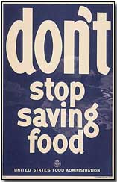
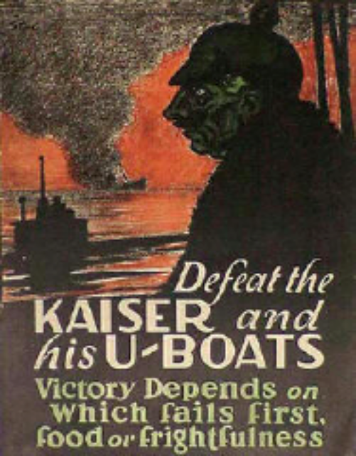

Rationing
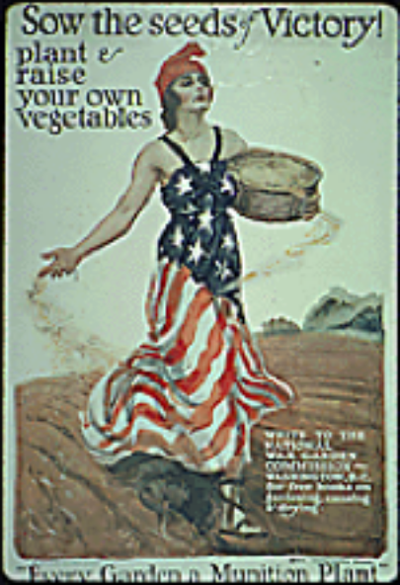

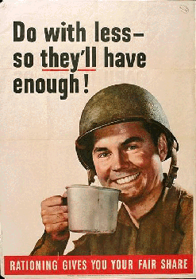

The government created a special group of officials and popular advertising agencies to come up with propaganda for the war.

Over There
Johnnie, get your gun,
Get your gun, get your gun,
Take it on the run,
On the run, on the run.
Hear them calling, you and me,
Every son of liberty.
Hurry right away,
No delay, go today,
Make your daddy glad
To have had such a lad.
Tell your sweetheart not to pine,
To be proud her boy's in line. (chorus 2X)
Johnnie, get your gun,
Get your gun, get your gun,
Johnnie show the Hun
Who's a son of a gun.
Hoist the flag and let her fly,
Yankee Doodle do or die.
Pack your little kit,
Show your grit, do your bit.
To the ranks,
From the towns and the tanks.
Make your mother proud of you,
And the old Red, White and Blue. (chorus 2X)
Over there, over there,
Send the word, send the word over there -
That they are coming,
They are coming,
The drums rum-tumming
Ev'rywhere.
So prepare, say a pray'r,
Send the word, send the word to beware.
We'll be over, we're coming over,
And we won't come back till it's over
Over there.

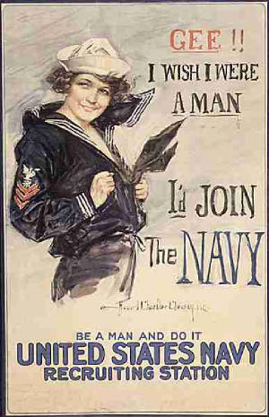
Join the Navy!

- What does it tell us about
American society at the time of
World War I?

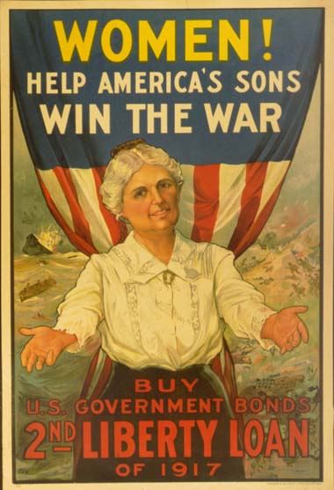

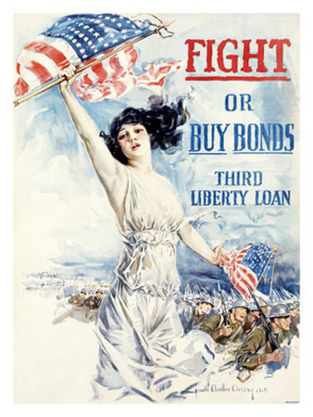
Liberty Bonds
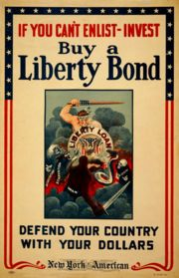
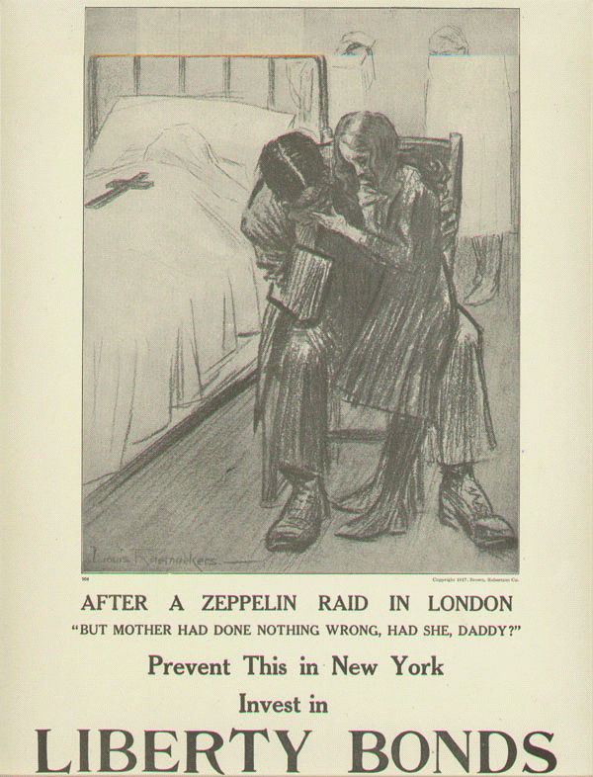
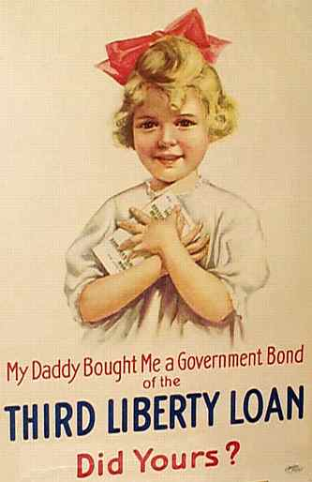

DOCUMENT # 2 Espionage Act (remember Alien and Sedition Acts under President Adams)

Sedition Acts
On April 19, 1918, a man said in Missoula that the United States Liberty Bonds were no good. That government would not back them up. That the man that bought them would never get his money back. That he would lose it. That the U.S. government was no good.

THE ESPIONAGE ACT OF 1917 and 1918
(1) The Espionage Act of June 15, 1917
SEC. 3. Whoever, when the United States is at war, shall willfully make or convey false reports or false statements with intent to interfere with the operation or success of the military or naval forces of the United States or to promote the success of its enemies and whoever, when the United States is at war, shall willfully cause or attempt to cause insubordination, disloyalty, mutiny, or refusal of duty, in the military or naval forces of the United States, or shall willfully obstruct the recruiting or enlistment service of the United States, to the injury of the service or of the United States, shall be punished by a fine of not more than $10,000 or imprisonment for not more than twenty years, or both.
(2) The Espionage Act of 1917 Amended, May 1918. (reenacted by Act of Mar. 3, 1921 current version codified at 18 U.S.C. §2388) Be it enacted, That section three of the Act, approved June I5, 1917, be amended to read as follows:
SEC. 3. Whoever, when the United States is at war, shall willfully make or convey false reports or false statements with intent to interfere with the operation or success of the military or naval forces of the United States, or to promote the success of its enemies, or shall willfully make or convey false reports, or false statements, or say or do anything except by way of bona fide and not disloyal advice to an investor . . . with intent to obstruct the sale by the United States of bonds . . . or the making of loans by or to the United States, or whoever, when the United States is at war, shall willfully cause . . . or incite . . . insubordination, disloyalty, mutiny, or refusal of duty, in the military or naval forces of the United States, or shall willfully obstruct . . . the recruiting or enlistment service of the United States, and whoever, when the United States is at war, shall willfully utter, print, write, or publish any disloyal, profane, scurrilous, or abusive language about the form of government of the United States, or the Constitution of the United States, or the military or naval forces of the United States, or the flag . . . or the uniform of the Army or Navy of the United States, or any language intended to bring the form of government . . . or the Constitution . . . or the military or naval forces . . . or the flag . . . of the United States into contempt, scorn, contumely, or disrepute . . . or shall willfully display the flag of any foreign enemy, or shall willfully . . . urge, incite, or advocate any curtailment of production in this country of any thing or things . . . necessary or essential to the prosecution of the war . . . and whoever shall willfully advocate, teach, defend, or suggest the doing of any of the acts or things in this section enumerated and whoever shall by word or act support or favor the cause of any country with which the United States is at war or by word or act oppose the cause of the United States therein, shall be punished by a fine of not more than $10,000 or imprisonment for not more than twenty years, or both....

- What was the purpose of Espionage Act?
- How did they limit the liberties of certain citizens?
- Were these acts reasonable under the circumstances?

The Enemy

- Why might this be effective propaganda?
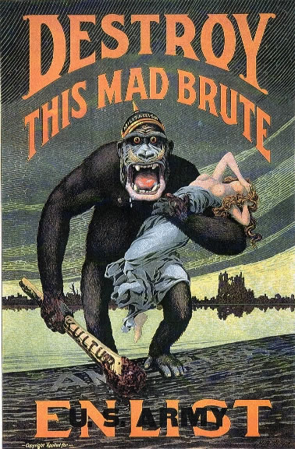
- How do these posters demonstrate nationalism and ethnocentrism?

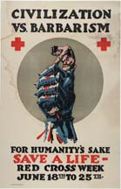

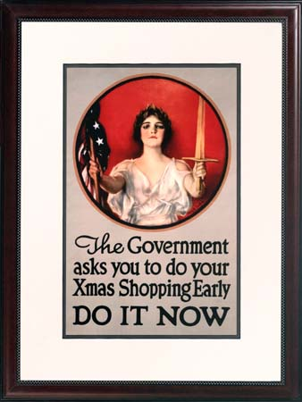
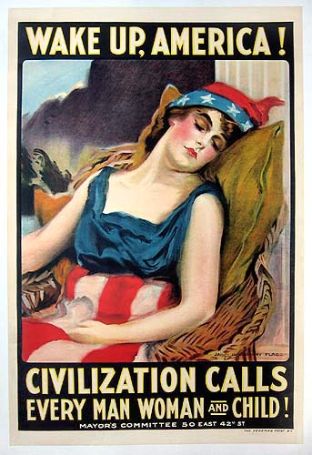

(1) How did women play a part in the war effort if they couldn’t fight with the
military?

(2) Why were production and consumerism so important to the U.S. during
WWI?

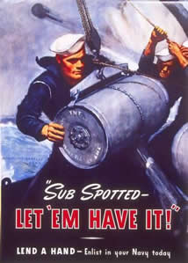

- What tactics did the government use to get men to enlist in the army?
- Do you think these tactics were effective? Why or why not?

DOCUMENT # 3
Schenck v. United States
During World War I, the Espionage and Sedition Acts were passed, making it illegal to speak badly about the government or America’s role in the war. Charles Schenck was arrested during this time period for distributing anti-war pamphlets.

A. Schenck Pamphlet

Assert Your Rights
The Socialist Party says that any individual or officers of the law intrusted with the administration of conscription regulations violate the provisions of the United States Constitution, the supreme law of the land, when they refuse to recognize your right to assert your opposition to the draft.
In exempting clergymen and members of the Society of Friends (popularly called Quakers) from active military service the examination boards have discriminated against you.
If you do not assert and support your rights you are helping to "deny or disparage rights" which it is the solemn duty of all citizens and residents of the United States to retain.
In lending tacit or silent consent to the conscription law, in neglecting to assert your rights, you are (whether knowingly or not) helping to condone and support a most infamous and insidious conspiracy to abridge and destroy the sacred and cherished rights of a free people. You are a citizen: not a subject! You delegate your power to the officers of the law to be used for your good and welfare, not against you.
They are your servants; not your masters. Their wages come from the expenses of government which you pay. Will you allow them to unjustly rule you?
No power was delegated to send our citizens away to foreign shores to shoot up the people of other lands, no matter what may be their internal or international disputes.
To draw this country into the horrors of the present war in Europe, to force the youth of our land into the shambles and bloody trenches of war crazy nations, would be a crime the magnitude of which defies description. Words could not express the condemnation such cold-blooded ruthlessness deserves.
Will you stand idly by and see the Moloch of Militarism reach forth across the sea and fasten its tentacles upon this continent? Are you willing to submit to the degradation of having the Constitution of the United States treated as a "mere scrap of paper"?
No specious or plausible pleas about a "war for democracy" can becloud the issue. Democracy can not be shot into a nation. It must come spontaneously and purely from within.
Democracy must come through liberal education. Upholders of military ideas are unfit teachers.
To advocate the persecution of other peoples through the prosecution of war is an insult to every good and wholesome American tradition.
You are responsible. You must do your share to maintain, support, and uphold the rights of the people of this country.
In this world crisis where do you stand? Are you with the forces of liberty and light or war and darkness?

Supreme Court Decision: Setting Precedent!
The Supreme Court ruled unanimously to affirm the decision of the district court against Schenck. Justice Oliver Wendall Holmes delivered the Court’s decision:
“We admit that in many places and in ordinary times the defendants in saying all that was said in their circular would have been within their constitutional rights. But the character of every act depends on the circumstances in which it is done. The most stringent protection of free speech would not protect a man falsely shouting fire in a theatre, and causing panic…The question in every case is whether the words used are used in such circumstances and are of such a nature as to create a clear and present danger that they will bring about substantive evils that congress has the right to prevent.”

Precedent – setting a standard for the future.

(1) What was the Court reasoning in Schenck?

DOCUMENT # 4 Civil Liberties vs. National Security
(1) Palmer Raids: With the power to deport, Attorney General, Alexander Palmer, and his assistant, J. Edgar Hoover, launched a crusade against the radical left. Beginning in the fall of 1919, between 5,000 and 10,000 suspected alien residents were arrested without warrants in what became known as the Palmer Raids. No evidence of a proposed revolution was uncovered; many of those arrested were found to be American citizens affiliated with a union or the “wrong” political party. The vast majority of arrestees were eventually released but hundreds of “enemy aliens”—including the anarchist Emma Goldman, a naturalized citizen who was “denaturalized”—were eventually deported to the Soviet Union. The Supreme Court failed to uphold the constitutional rights of the American citizens arrested under the acts. U.S. Supreme Court Justice Oliver Wendell Holmes, Jr. justified the repression in a famous decision in which he stated that when the exercise of free speech constituted a “clear and present danger” to America—“danger” as defined by the government—the authorities could legitimately suspend the First Amendment. The Palmer Raids continued into 1920. As anti-war scientists and protesters, union members, and socialist leaders continued to be brutally arrested without warrants and held without trial, however, public approval shifted away. Opposition began to organize. For example, in 1920 the American Civil Liberties Union formed to protest the violation of constitutional rights such as arrest without warrant, unreasonable search and seizure, the denial of due process, and police brutality. Its first director, Roger Baldwin, was a pacifist and a member of the IWW (Industrial Workers of the World). Palmer himself suffered a series of embarrassments that hurried the demise of his political influence. For example, he predicted a communist uprising on May 1, 1920, and caused such panic that the New York State legislature refused to seat five Socialists who had been elected. When the uprising did not occur, sharp resentment and skepticism replaced panic. By 1921, the Red Scare was effectively over. It stands as a reminder of how national-security interests can be used by government to suppress dissenting political ideas even beyond the period of warfare. This is especially true when those expressing the ideas can be vilified as “foreign.” Indeed, any segregated group that threatened the political status quo came under suspicion.

(2) Eugene Debs, Anti-War Speech, Canton, Ohio (June 16, 1918) “Wars throughout history have been waged for conquest and plunder. In the Middle Ages when the feudal lords who inhabited the castles whose towers may still be seen along the Rhine concluded to enlarge their domains, to increase their power, their prestige and their wealth they declared war upon one another. But they themselves did not go to war any more than the modern feudal lords, the barons of Wall Street go to war. The feudal barons of the Middle Ages, the economic predecessors of the capitalists of our day, declared all wars. And their miserable serfs fought all the battles. The poor, ignorant serfs had been taught to revere their masters; to believe that when their masters declared war upon one another, it was their patriotic duty to fall upon one another and to cut one another’s throats for the profit and glory of the lords and barons who held them in contempt. And that is war in a nutshell. The master class has always declared the wars; the subject class has always fought the battles. The master class has had all to gain and nothing to lose, while the subject class has had nothing to gain and all to lose—especially their lives.
They have always taught and trained you to believe it to be your patriotic duty to go to war and to have yourselves slaughtered at their command. But in all the history of the world you, the people, have never had a voice in declaring war, and strange as it certainly appears, no war by any nation in any age has ever been declared by the people.
And here let me emphasize the fact—and it cannot be repeated too often—that the working class who fight all the battles, the working class who make the supreme sacrifices, the working class who freely shed their blood and furnish the corpses, have never yet had a voice in either declaring war or making peace. It is the ruling class that invariably does both. They alone declare war and they alone make peace.
Yours not to reason why;
Yours but to do and die.
That is their motto and we object on the part of the awakening workers of this nation.
If war is right let it be declared by the people. You who have your lives to lose, you certainly above all others have the right to decide the momentous issue of war or peace.”
(1) Does this quote pose a clear and present danger?

(3) Senator Robert La Follette Defends Freedom of Speech (1917)
I think all men agree that in times of war the citizens must surrender some rights which s/he would have in peace time in order to help the common good of the country during the war. But, the right of the people to control their own government through freedom of speech is NOT one of the rights that the people should be asked to give up during war. In times of war, it is even more important than in times of peace that the people have the right to control their government. The people must be careful that the military doesn’t try to take too much power. More than anything, the people and their representatives in Congress must keep their rights of free speech. Even more than in times of peace, it is necessary that the public discussion of government policies be open and free. I believe that it is the right of the citizens of this country to discuss every decision that is made during this war, and to discuss freely how peace should be decided at the end of the war.

The U.S. involvement in World War I was supported by the U.S. population. This support was rallied by the use of propaganda.

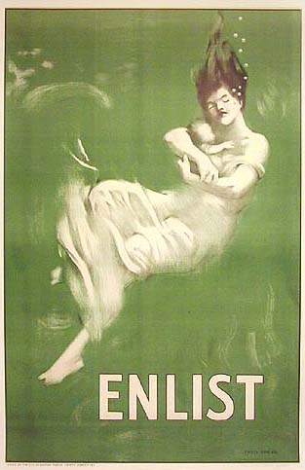

AIM: How did those at home, in America, become part of the war effort?

MOTIVATION: Military advertisements and Enlist – Green sinking girl OH…

- BEFORE OH is UP!!!!  Can anyone give me the saying for the army? | - Describe what you see.
(2) Do these ads look familiar to you? Have you  seen ads like them? | - Why would this woman be under water? (connection to the Lusitania)
- Why might these ads be effective in recruiting members of the military? | (3) How might this poster make people feel?
- What are some of the reasons people join the military? | - Do you think this poster may have encouraged patriotism? Explain.

TASKS
- Walk around the room and look at the posters. In your group answer the questions on the posters.
- Fill out the chart. (continue after sitting)

APPLICATION: Discuss propaganda posters.

SUMMARY: Answer Aim –
- How did the people at home become part of the war effort?
- Is this method of gaining public support still used by our government today?

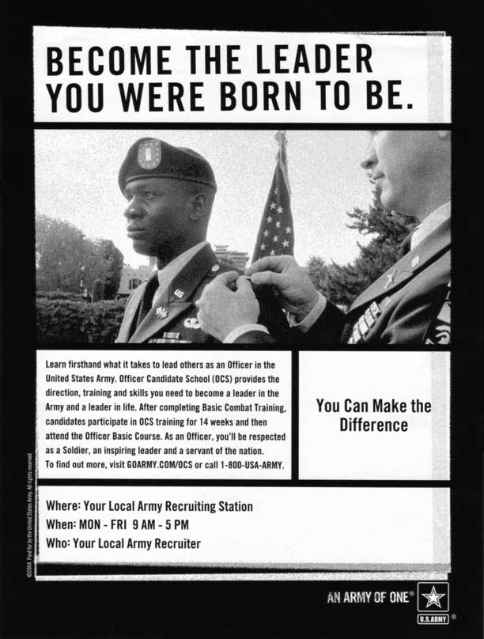

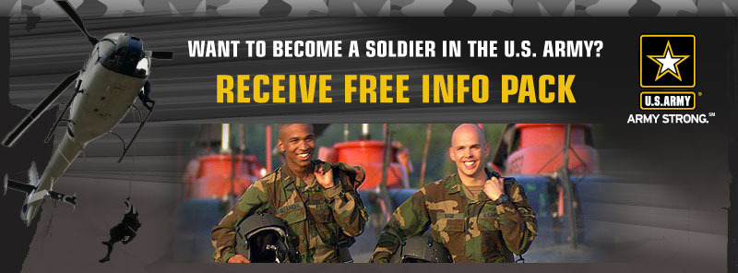

VOCABULARY
Industrial Focus
Railway Administration Act gave de facto control of the railroads—the major source of transportation—to the federal government. The War Labor Board, the War Industries Board, and a slate of other government agencies centralized commerce in the name of supporting the war effort. Fuel rationing, the draft, price controls—these and many other measures thrust the federal government deeply into the economic lives of the average American.
In the mining town of Bisbee, Arizona, the IWW recruited members among Mexican and European workers who routinely labored at lower-paying jobs than native-born Americans. In June 1917, the IWW presented a list of demands to Bisbee’s mining companies, including an end to discrimination against minority and foreign workers. When the companies turned down every demand, a strike was called. Then a rumor erupted: the IWW had been infiltrated by pro-Germans. At 2 a.m., hundreds of armed vigilantes rounded up nearly 1,200 men, whom they forced into 24 cattle cars of a train, shipped them to New Mexico, and abandoned them in a remote area. The deportees were without shelter for weeks until U.S. troops escorted them to facilities where many were held for months. The authorities in Bisbee guarded all roads into town to prevent the men, or any other undesirables, from entering. Other local workers were put on trial and deported if found guilty of disloyalty to the mining companies. A federal commission investigated the deportations but found no federal laws had been violated. The matter was referred to the state of Arizona, which took no action against the mining companies.

