AP US History

What should the government do about the Great Depression?

Examine the stations at your desk. Based on the readings, choose two pictures below to describe how these groups are affected by the Great Depression.

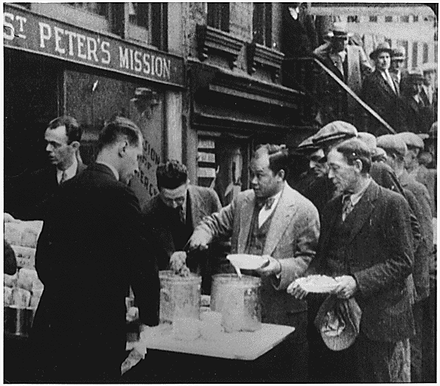  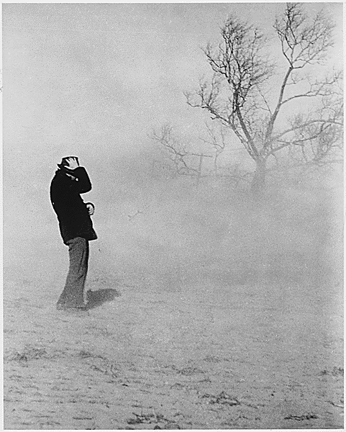 | 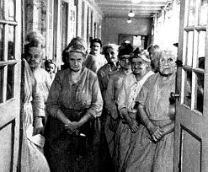  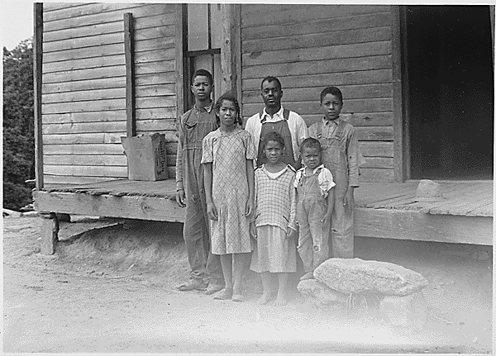
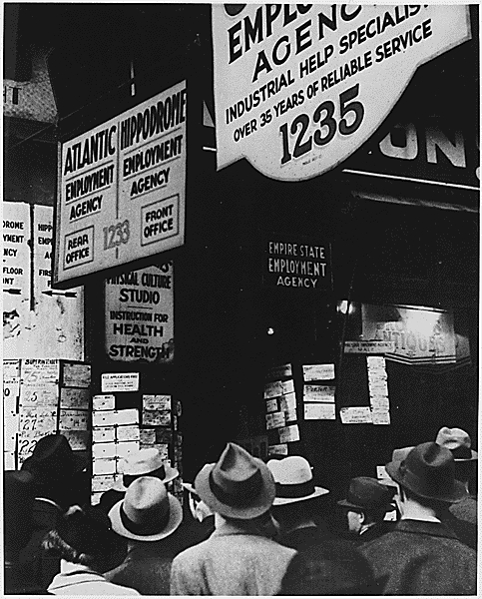 | 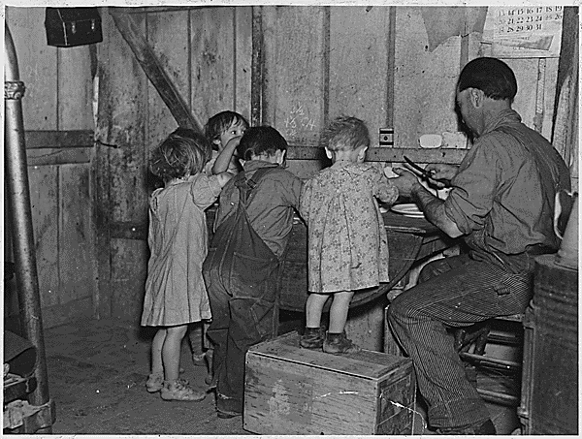
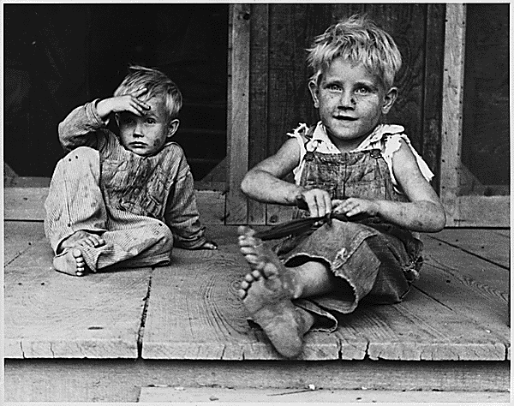 | 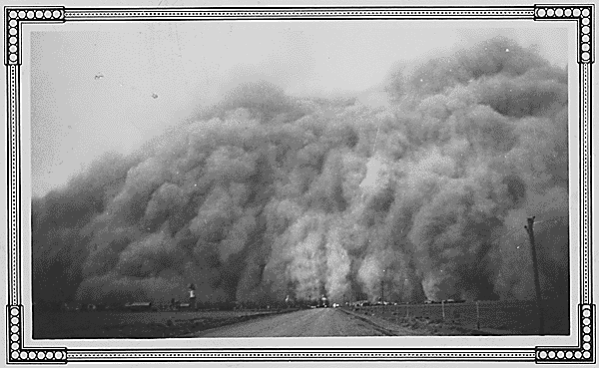
A) John Steinbeck, 1939
“Carloads of homeless and hungry; thousands more everyday. They searched over the mountains, hungry and restless-looking for work to do- to lift, to push, to pull, to pick, to cut- anything for food. The kids are hungry. We got no place to live…. A homeless hungry man drives with his family in search of food and work. “Where can we sleep for the night?” he asks. He is told about the Hooverville near the river. He never had to ask again because there was a Hooverville on the edge of every town. The town was close to the water; and the houses were tents, paper houses, and piles of junk. If you did not have a tent, you could go to the city dump and collect cartons and cardboard. And when the rains came the house melted and washed away. Many families settled in Hooverville and then searched the area for work; the little money that families had went to gas to keep searching.”

B) President Hoover Explains His Philosophy of Rugged Individualism (1928)
“During [World War I] we necessarily turned to the government to solve every difficult economic problem…. However justified in war time, if continued in peace-time it would destroy not only our American system but with it our progress and freedom as well.
When the war closed, the most vital of issues both in our own country and around the world was whether government should continue their wartime ownership and operation of many [instruments] of production and distribution. We were challenged with a... choice between the American system of rugged individualism and a European philosophy of diametrically opposed doctrines of paternalism and state socialism. The acceptance of these ideas would have meant the destruction of self-government through centralization...
The greatness of America has grown out of a political and social system and a method of [a lack of governmental] control of economic forces distinctly its own our American system which has carried this great experiment in human welfare farther than ever before in history.... And I again repeat that the departure from our American system... will jeopardize the very liberty and freedom of our people, and will destroy equality of opportunity not only to ourselves, but to our children....”

C) President Herbert Hoover Gives His Opinion on the Role of the Government (1930)
“I do not believe that the power and the duty of the government should be used to help relieve individual suffering. The lesson should constantly be stated that even though the people support the government, the government should not support the people.”

D) Comments from Franklin Delano Roosevelt
“I have told you in other speeches that for at least two years after the crash, the only efforts made by Hoover to stop unemployment were to deny that there was even a problem. We need to review our values.”

“Never in history have the interests of all the people been so united in a single economic problem…danger to one is danger to all…Can Republican leaders tell us the problem will fix itself…while they voice these promises men and women are starving…I pledge you, I pledge myself, to a new deal for the American people.”
–Accepting the Democratic nomination for the presidency, July 2, 1932

“This great Nation will endure as it has endured, will revive and will prosper. So, first of all, let me assert my firm belief that the only thing we have to fear is fear itself--nameless, unreasoning, unjustified terror which paralyzes needed efforts to convert retreat into advance…. Values have shrunken to fantastic levels; taxes have risen; our ability to pay has fallen; government of all kinds is faced by serious curtailment of income; the means of exchange are frozen in the currents of trade; the withered leaves of industrial enterprise lie on every side; farmers find no markets for their produce; the savings of many years in thousands of families are gone…. More important, a host of unemployed citizens face the grim problem of existence, and an equally great number toil with little return. Only a foolish optimist can deny the dark realities of the moment. Compared with the perils which our forefathers conquered because they believed and were not afraid, we have still much to be thankful for. Nature still offers her bounty and human efforts have multiplied it. Plenty is at our doorstep… Our greatest primary task is to put people to work. This is no unsolvable problem if we face it wisely and courageously. It can be accomplished in part by direct recruiting by the Government itself, treating the task as we would treat the emergency of a war, but at the same time, through this employment, accomplishing greatly needed projects to stimulate and reorganize the use of our natural resources.” –First Inaugural Address, March 4, 1933

E) Hoover Responds to FDR at Madison Square Garden (October 31, 1932)
“The plan of FDR means despair for the country…you cannot force the government on the people without the people wanting it…. Expansion of government involvement in business means that the government will have to place greater control over other aspects of life…free speech will not live many hours after free industry and free commerce die…every step toward government involvement into business is a step toward less liberty…it will increase abuse and corruption, stop initiative and intervention, undermine the leadership of our people…”

- Describe Hoover’s approach.
- Agree/Disagree?
- Describe FDR’S reaction.
- Agree/disagree?
- Was Hoover’s response believable?

The Elderly and African Americans
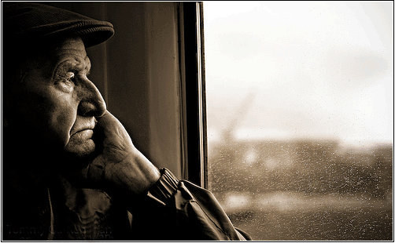
There were no services for the aging of America. They were out of work and out of money. The government did not provide for the needs of those who could not provide for themselves. The elderly did not have retirement fund to take care for them in their later years. People were also living longer and were not prepared for their older years.

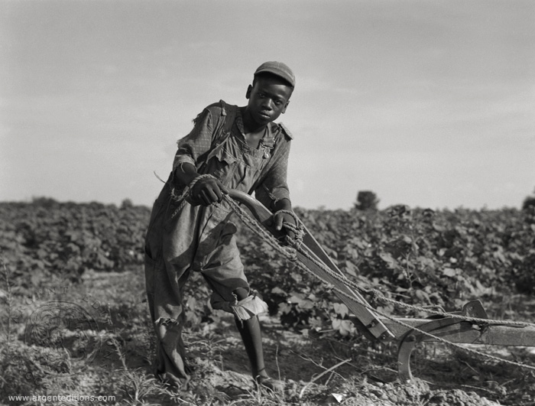
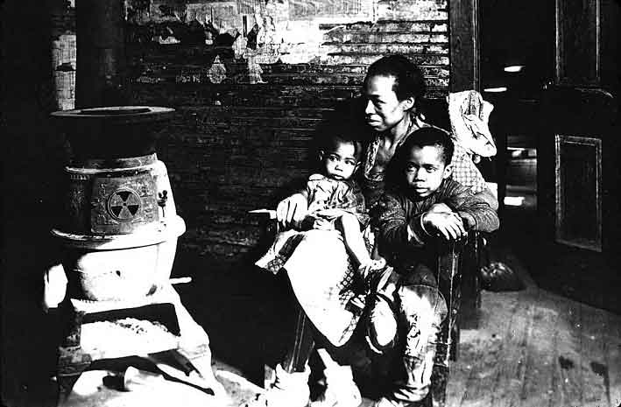
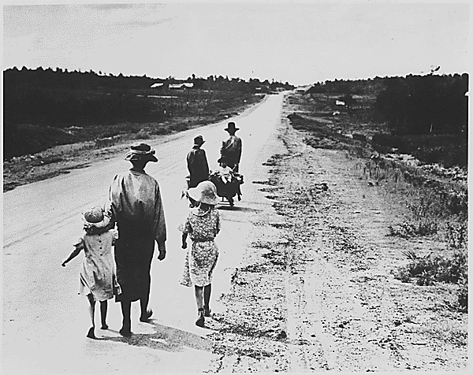
Although the suffering of the 1930’s was severe for many people, it was especially harsh for African Americans. Hard times were already a fact of life for many blacks, as one African American man notes, “The negro was born in depression. It didn’t mean too much to him, the Great American Depression…the best he would be is a janitor or a porter (caretaker) or a shoeshine boy. It only became official when it hit the white man.” Nonetheless, the African American community was hit hard by the Great Depression. In 1932, the unemployment rate among African Americans stood at over 50%, while the overall unemployment rate was about 25%.

Unemployment
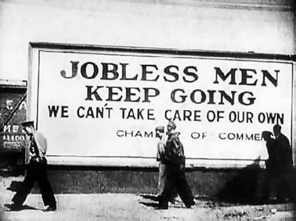

“Brother, Can You Spare a Dime?”
Song by E.Y. Harburg and J. Gorney, 1930

They used to tell me that I was building a dream
And I followed the mob.
When there was earth to plow or guns to bear
I was always there—right on the job.

They used to tell me I was building a dream
With peace and glory ahead.
Why should I be standing in line
Just waiting for bread?
Results of Drastic Deflation (Decrease in normal cost of a good or service)

Here are some prices advertised by a market in Los Angeles on September 6, 1932:

Bread, loaf - $.05
Lettuce, per head- $.01
Spring Lamb Chops, per pound- $.12
Choice Sirloin Steak, per pound - $.20
Tomatoes, 8lbs - $.05
Sliced Bacon, per pound $.10

Once I built a railroad, made it run
Made it race against time
Once I built a railroad—now it’s done.
Brother, can you spare me a dime?

Once I built a tower to the sun,
Brick and rivet and lime.
Once I built a tower—now it’s done.
Brother, can you spare a dime?

Children
My dear Mrs. Roosevelt,  You many think that I am a very insignificant (not important) person to be writing to a person of your standing and ability, but by reading your article and hearing our talks, I know you are real and have a real interest in people, even my dear little needy boys and girls of the mountain schools.  I am Rural Supervisor of Schools in my county. I have forty schools to supervise (overlook). Due to insufficient (not enough) clothing and food, many are unable to attend schools.  I wish it were possible for you to see some of the conditions. It is not uncommon for a child to have but one dress or shirt. They have to stay at home the day the mother launders (washes) them.  I am just wishing that in some of your groups that it would be possible to interest them in our needs…I hope you will not consider me rude for writing. I have my heart in the work. I realize a hungry and cold child cannot learn much.  Yours very truly,  C.B.S. | Dear Mrs. Roosevelt,  I am writing this letter in the hope that you will answer in my favor. My father H.C. had been in bed from a stroke for almost a year. We have no money and my brother works, but make $3.00 a week and there are eight in our family.  My stepmother is very good to me and I try to help her. She takes in washings and I have to walk for six or eight blocks and then carry the washings home. I have to go to school in the morning and it has been very cold here. If you could send me a bicycle to ride when I go after washings for her I shall appreciate it. I am in the eighth grade of school and work very hard to meek passing grades. If you would do this for me, I’d be able to help my stepmother more. If you send me one, I would like a girls bicycle. I am about 4 feet 3 inches tall, so if you send me one you can judge as to what size.  Loving and appreciating,  A.L.C.
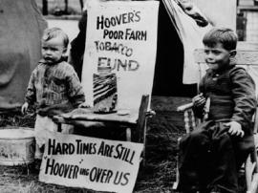
Hoverville Children, 1932
Two small children during the Great Depression sit beside a donation jar labeled “Hoover’s Poor Farm Tobacco Fund.” They are part of a squatter community, of a kind known bitterly as “Hoovervilles” because of the President’s inability to even admit to the existence of a national crisis. A sign in the front reads, “Hard Times are still Hoovering over US.”

Farmers

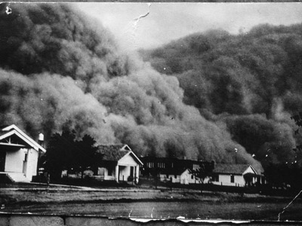
In 1931, a drought (no water, a dry season) returned to the plains. In the fall of 1933, began dust storms, which gave the area a new name, the Dust Bowl. Dust blew across the land, darkened the skies, and made the plains area (the Midwest parts of America) almost unlivable for man or livestock. Millions of acres of farmland were damaged. Sometimes, the sand piled up so high it covered farms, burying roads, fences, and even houses. Many farmers tried to move and head to better land in California. It was a period of misery.
“Carloads of homeless and hungry came; thousands more everyday. They came hungry and restless—looking for work to do—to lift, to push, to pick, to cut—anything for food. The kids were hungry, we got no place to live. Like ants, we run around looking for work, for food, and most of all for land. ‘Where can we sleep at night?’ asked a homeless man. He is told about the Hooverville. He never had to ask again because there was a Hooverville on the edge of every town.

The houses were made of cloth and garbage. If you did not have a tent, you could go to the city dump and collect cartons and cardboard. And when the rains came, the house melted and washed away. Many families settled in Hooverville and then searched the area for work.”

-John Steinbeck, 1939

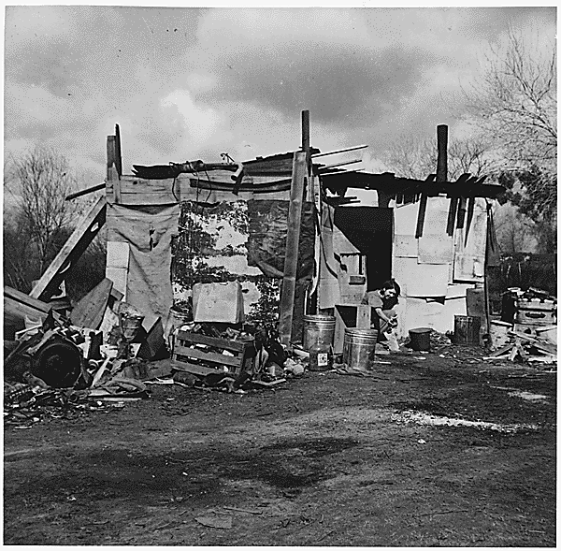
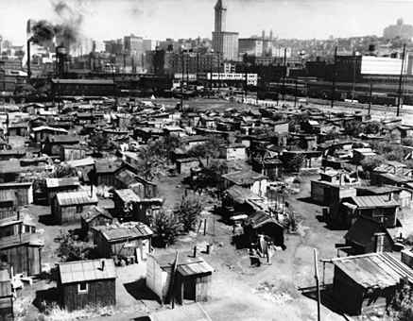

Free Food for the Needy
Breadlines and Soup Kitchens

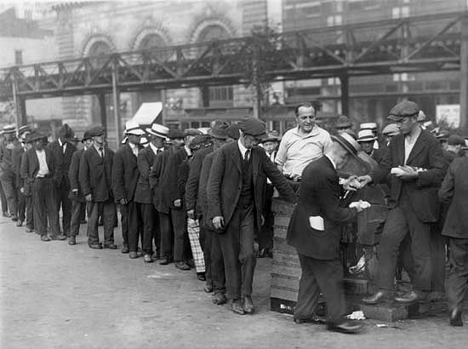
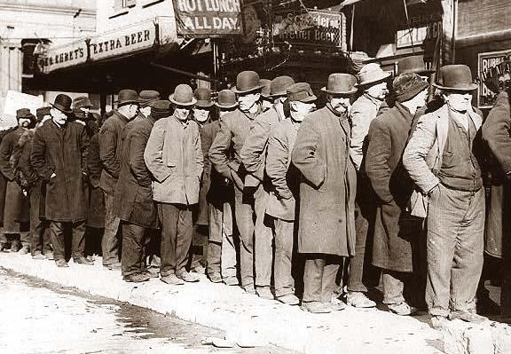

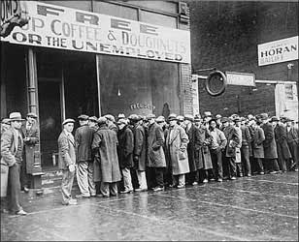
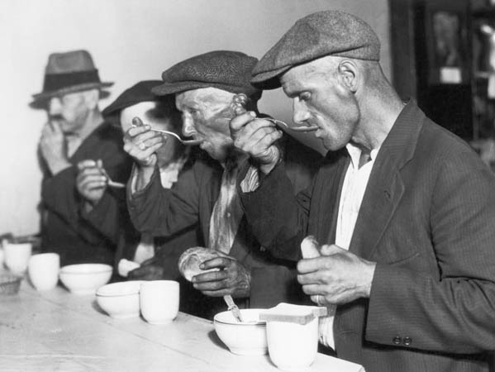
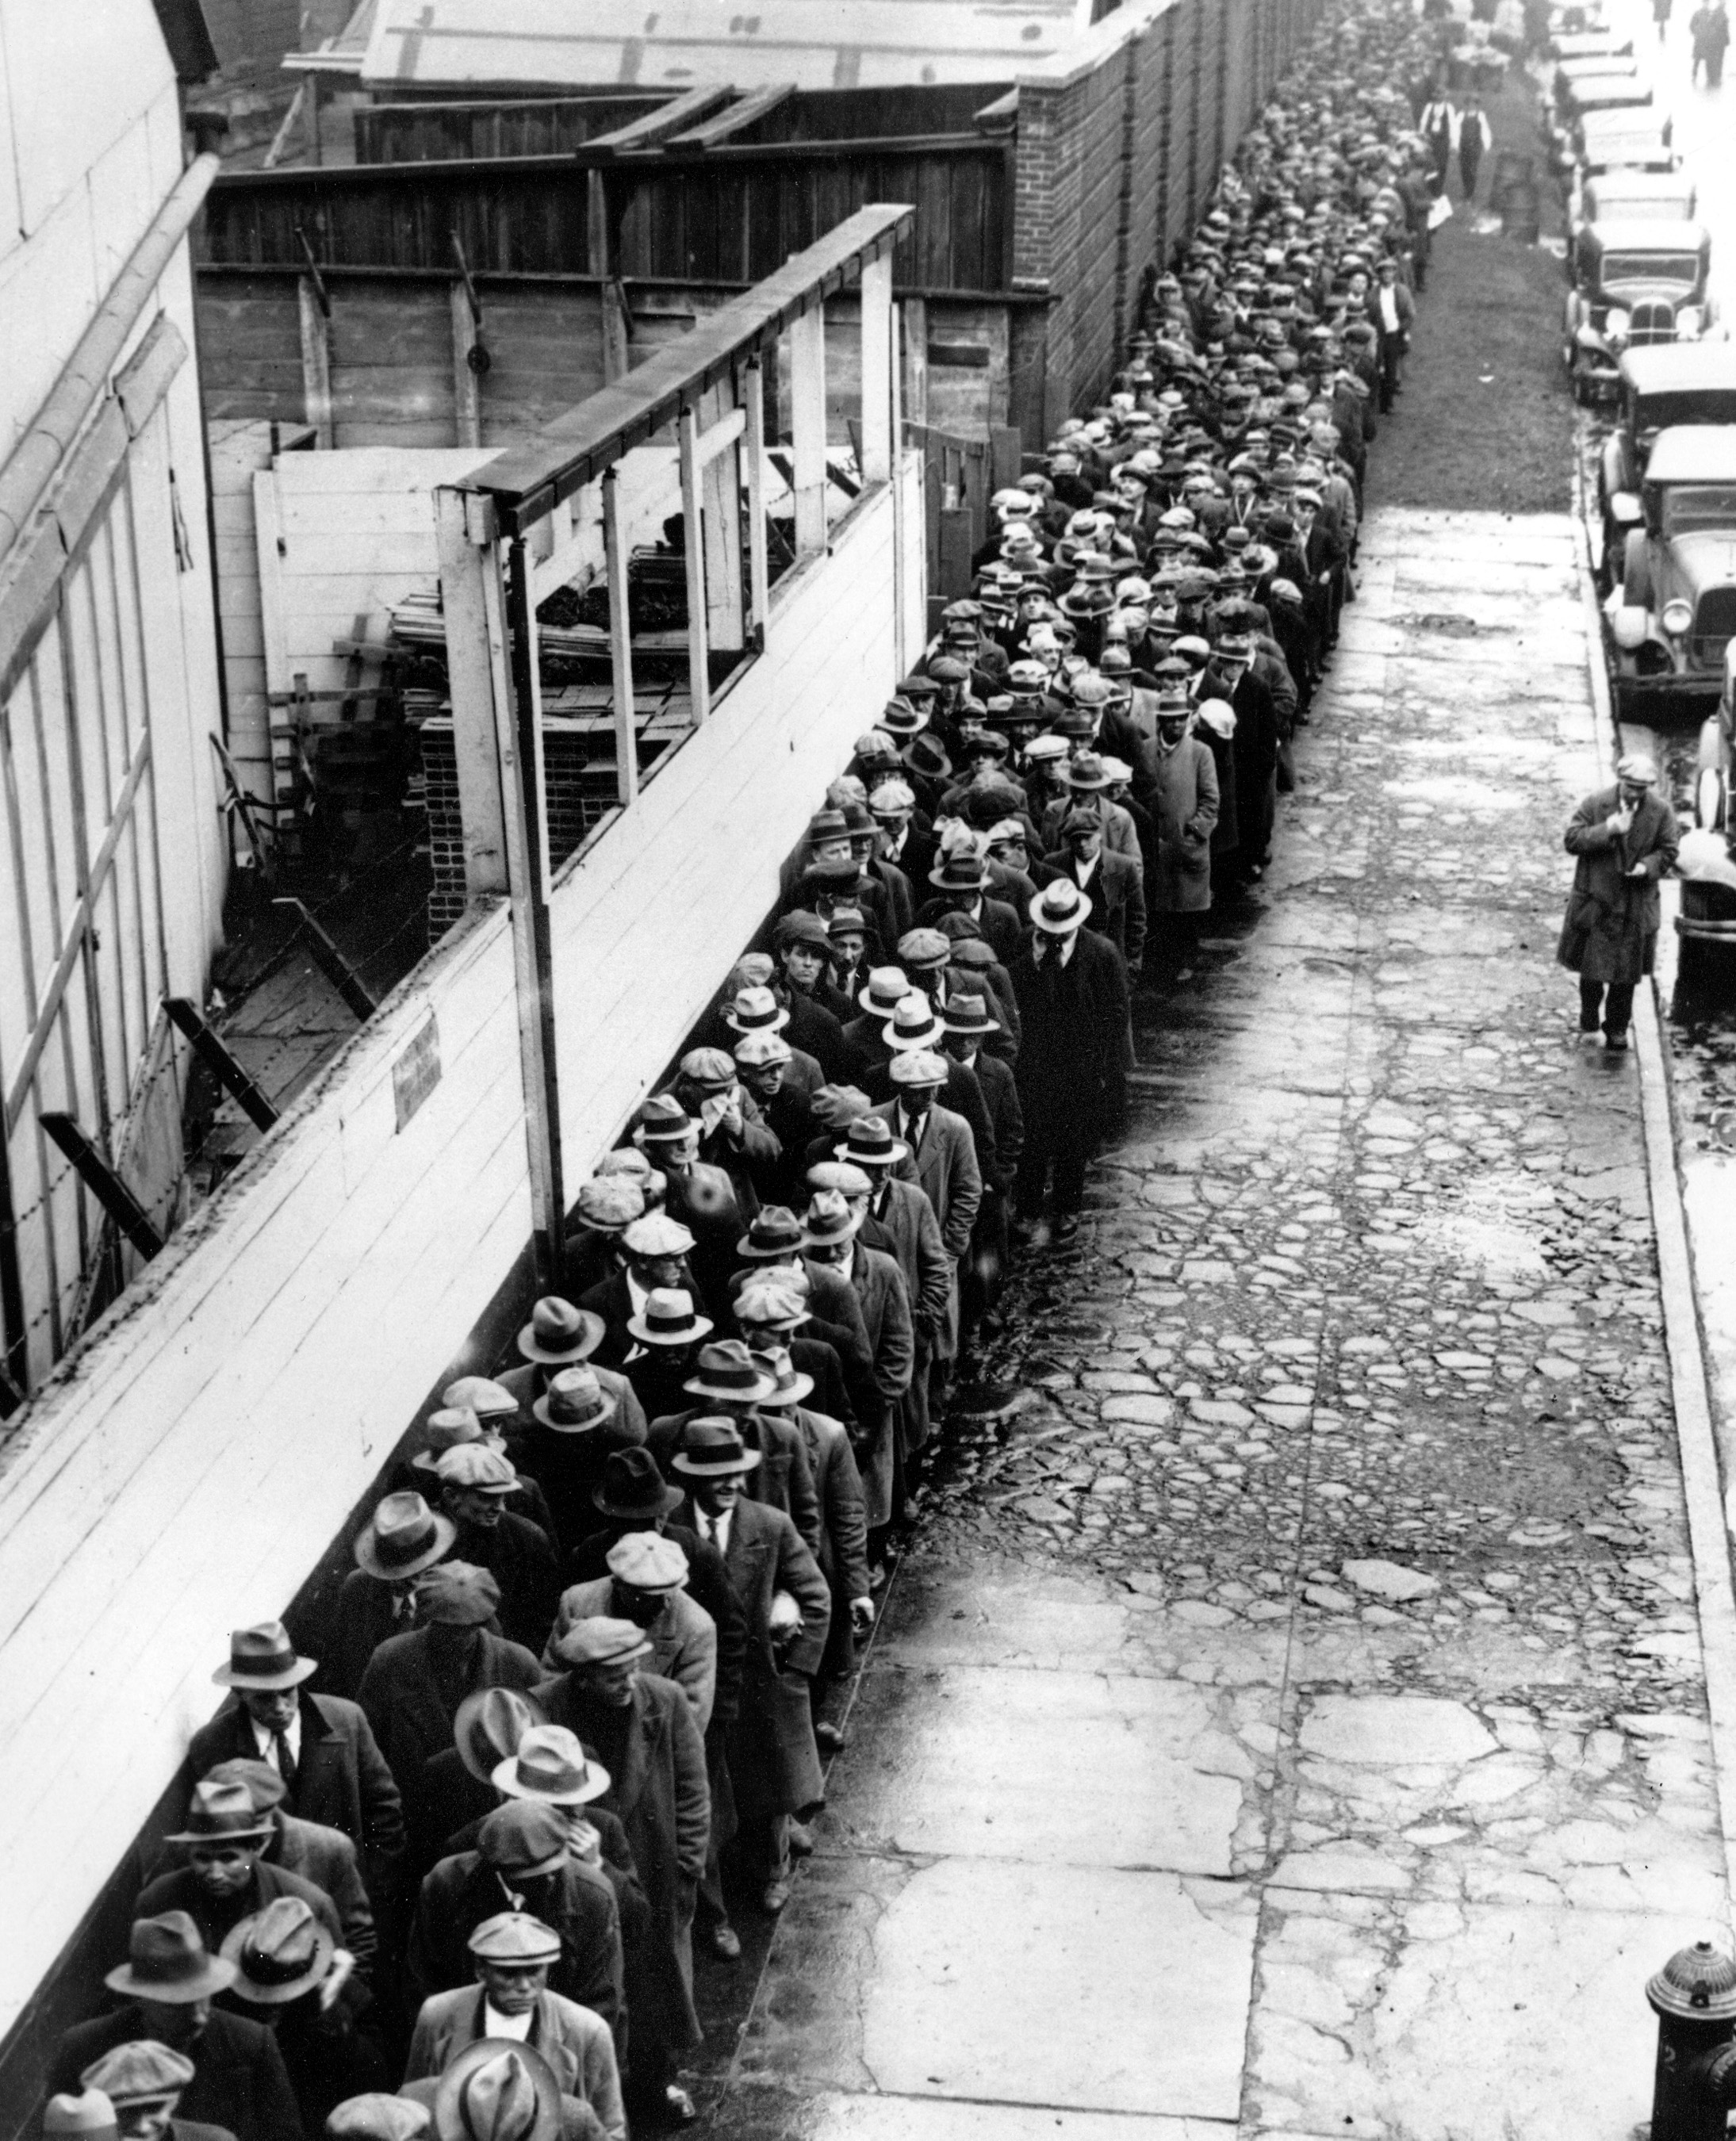

Unemployment Pictures


